≠

*[Geophysical Research Letters]*

Supporting Information for

**Emergent constrained projections of mean and extreme warming in China**

Ziming Chen1,2,3, Tianjun Zhou1,2, Xiaolong Chen1, Wenxia Zhang1, Meng Zuo1, Wenmin Man1, Yun Qian3

*1 LASG, Institute of Atmospheric Physics, Chinese Academy of Sciences, Beijing 100029, China*

*2 College of Earth and Planetary Sciences, University of Chinese Academy of Sciences, Beijing 100049, China*

*3 Atmospheric Sciences and Global Change Division, Pacific Northwest National Laboratory, Richland, WA, USA*

Contents of this file

Text S1 to S7

Table S1 to S7

Figure S1 to S23

**Text S1. Observational datasets**

The observational dataset we usedis the homogenized gridded dataset CN05.1 (Wu & Gao, 2013). CN05.1 is constructed based on more than 2400 observation stations in China. The data are interpolated using the “anomaly approach” (New et al., 2000). Compared with other observational datasets, CN05.1 has been proven to have good performances in climatology and long-term trend on mean state and extreme temperature in China (Wu & Gao, 2013).

Multiple observational datasets are used to correct the present-day model biases (Table S5 in the Supporting Information). The monthly gridded observational surface temperature datasets used are (1) Cowtan and Way version 2 (Cowtan & Way, 2014); (2) Berkeley Earth Surface Temperature (BEST) (Rohde et al., 2013); (3) NASA Goddard Institute for Space Studies Surface Temperature version 5 (GISTEMP v5) (Lenssen et al., 2019); and (4) NOAA Global Surface Temperature version 5.0 (Vose et al., 2012; H.-M. Zhang et al., 2019).

Since observation-based datasets may be a blend of land near-surface air and sea surface temperature (GBST), the blending biases may cause model-observation mismatches (Cowtan et al., 2015). To avoid the blending bias, following Tokarska et al. (2020), we add an estimate of the blending effect, which is represented by the difference between GSAT and GBST, to the GBST observations. The blending effect is 0.013 $±$ 0.005 $℃$/10 yr (Tokarska et al., 2020).

The period 1981~2014 is chosen to calculate the GSAT trend and constrain the projected warming. The warming trend in 1981~2014 has been dominated by the response to greenhouse gases, with no significant aerosol cooling trend (Jiménez-de-la-Cuesta & Mauritsen, 2019; Liang et al., 2020; Nijsse et al., 2019; Tokarska et al., 2020; Z. Chen et al., 2022).

**Text S2. Hierarchical emergent constraint (HEC) framework to constrain local projected warming by using GSAT**

Based on the physical link between future GSAT warming (${GSAT}_{i}$) and present-day GSAT warming trend (X) in 1981–2014, we establish the linear regression between ${GSAT}_{i}$ and $X_{i}$ obtained from climate models, following (Tokarska et al., 2020):

${GSAT}_{i}^{C1}={GSAT}_{i}−ρ^{'}(X_{i}−X_{O})$, (1)

where $ρ^{'}$ is the inter-model regression coefficient, i represents individual CMIP6 model. Since we use the observations in the current climate ($X_{O}$) to constrain ${GSAT}_{i}$, the uncertainty in the observations should be considered. Under the Gaussian assumptions that relate the observations to the current climate (Bowman et al., 2018), the corrected coefficient (R) in the observations is the ratio between the variance across models ($σ_{X}^{2}$) and observational datasets ($σ_{O}^{2}$):

$R=σ_{X}^{2}/σ_{O}^{2}$. (2)

The regression coefficient is multiplied by $\frac{1}{1+R^{−1}}$ to correct $ρ_{ }^{'}$ (Chen et al., 2020). If the R is much larger than 1, the correction effect can be neglected. Based on equation (1) (Eq. (1)) and Eq. (2), the constrained GSAT warming (${GSAT}_{i}^{C1}$) expressed as:

${GSAT}_{i}^{C1}={GSAT}_{i}−ρ(X_{i}−\overline{X_{O}})$, (3)

where $ρ$ is the corrected regression coefficient, i.e., $\frac{ρ^{'}}{1+R^{−1}}$. $\overline{X_{O}}$ represents the ensemble mean across multiple observational datasets.

**Text S3. Pattern scaling**

We scale the regional mean and extreme warming over China by using the constrained GSAT changes (${GSAT}_{i}^{C1}$), based on the relationship between GSAT warming and the local warming (Figure 2, and Supplementary Figures S4 to S6, S9 to S10):

$Y_{i}^{C1}=Y_{i}− ρ_{C1}({GSAT}_{i}−{GSAT}_{i}^{C1})$, (4)

where $Y_{i}$ and $Y_{i}^{C1}$ represent the local projected warming in the raw projection and constrained projection. And $ρ_{C1}$ denotes the regression pattern between the GSAT warming and local warming (Figure 2, and Supplementary Figures S4 to S6). Based on Eq. (3) and Eq. (4), the local projected warming constrained by GSAT can be expressed as:

$Y_{i}^{C1}=Y_{i}− ρ_{C1}ρ(X_{i}−\overline{X_{O}})$. (5)

Since the constrained GSAT warming is useful for projecting other climate quantities that scale well with GAST changes (Hu et al., 2021; Lee et al., 2021), by using the observationally constrained GSAT warming and pattern scaling method, we can narrow down the model uncertainty of local projected warming related to the GSAT warming.

**Text S4. Method for further correcting the local projected warming constrained by local residual warming trend**

We further correct the local projected warming by using the local residual warming trend ($trend_{res}$) in the observation. The local residual warming is defined as the surface air temperature increase after deducting the GSAT mean warming. We consider the $trend_{res}$ to be the local warming due to the local feedback. Over the region where the local projected warming constrained by GSAT ($Y_{i}^{C1}$) is significantly correlated with the $trend_{res}$ across models (stippling in Supplementary Figures S11 to S14), the $Y_{i}^{C1}$ will be corrected by using the observed $trend_{res}$ ($trend_{res,obs}$):

$Y_{i}^{C2}=Y_{i}^{C1}−ρ_{C2}(trend_{res,i}−trend_{res,obs})$, (6)

where $Y_{i}^{C2}$ is the projected mean warming or temperature extremes constrained by the GSAT and the $trend_{res,obs}$. $ρ_{C2}$ represents the significant regression coefficient between the $trend_{res,i}$ and $Y_{i}^{C1}$ across models (Supplementary Figures S11 to S14). Over other region without significant regression coefficient, we set the $ρ_{C2}$ as 0.

When we get the emergent constraint coefficients according to Equation (1) to (6), we constrain each ensemble member for each model, and make inter-member ensemble mean for each model. And then we make inter-model ensemble mean and show the inter-model range of 5th~95th percentile in Supplementary Table S3.

**Text S5. Leave-one-out perfect model test**

Following Brunner et al. (2020) and Hersbach (2000), we apply a leave-one-out perfect model test to evaluate the skill of constrained projection. The brief descriptions are given below by taking model i as an example:

1. All the ensemble members of model i are removed from the CMIP6 ensemble to take as the pseudo-observation.
2. We use the surface air temperature from the historical run of model i to calculate the GSAT warming trend and the local residual warming trend. For model i with more than one ensemble member, we would calculate the GSAT warming trend and the local residual warming trend for each member, and then make an inter-member ensemble mean.
3. The projected warming over China would be constrained by using the pseudo-observation warming trends in 2), based on the Eq. (3), Eq. (5), and Eq. (6).
4. To measure the quality of constrained projection, we calculate the root-mean-square error (RMSE) and the continuous ranked probability skill score (CRPSS) between the constrained projection and pseudo-observation warming. In addition, we also calculate the RMSE and CRPSS between the raw projection and pseudo-observation warming for comparison.
5. We repeat the steps above for all models in the ensemble and all the emission scenarios, and obtain the RMSEs and CRPSSs for each model under the four emission scenarios.

The RMSE is defined as:

$RMSE_{i}=\frac{1}{n}\sum_{k}^{n}{w_{k}{\left(Y_{i}^{C2}−Y_{pse−obs}\right)}^{2}}$, (7)

where k labels the considered grid points over China, and the weights $w_{k}$ is the cosine of latitude. $Y_{i}^{C2}$ denotes the local projected warming constrained by the GSAT warming and the local residual warming in the pseudo-observation model, while $Y_{pse−obs}$ denotes the local warming projected by the pseudo-observation model.

The CRPSS is defined as:

$CRPSS\left(P, Y_{pse−obs}\right)=\int_{−∞}^{∞}{{\left[P\left(Y\right)−P_{pse−obs}\left(Y\right)\right]}^{2}dY}$, (8)

where $P\left(Y\right)$ and $P_{pse−obs}$ are the cumulative distributions of projection in the multi-model ensemble and the pseudo-observation model, respectively. $P\left(Y\right)$ and $P_{pse−obs}$ can express as:

$P\left(Y\right)=\int_{−∞}^{Y}{p(x)dx}$, (9)

$P_{pse−obs}(Y)=H(Y−Y_{pse−obs})$, (10)

where H is the Heaviside function, which is:

$H\left(a\right)=\left\{\begin{aligned}0, where a<0 \\ 1, where a≥0\end{aligned}\right.$. (11)

For any cumulative distribution, $P\left(Y\right)∈[0,1]$, while $P\left(−∞\right)$ and $P\left(∞\right)$ are 0 and 1, respectively. The CRPSS can measure the difference of cumulative distribution between the projection and pseudo-observation future. The minimal value of zero in CRPSS would be only achieved for $P\left(Y\right)≡P_{pse−obs}$, which is a perfect deterministic projection. So a low CRPSS suggests a high quality of constrained projection (Hersbach, 2000).

**Text S6. Method for separating the sources of projection uncertainty**

We estimated the contribution of different uncertainties in the constrained projection, following Hawkins & Sutton (2009) and Simpson et al. (2021). The projection uncertainty of projected warming in a given emission scenario can be partitioned into climate internal variability (IV) and model uncertainty (Hawkins & Sutton, 2009). Each component on the right of Equation (6) is uncertain, although part of model uncertainty would be reduced after emergent constraint. The model uncertainty includes the different components, including the reduced uncertainty explained by the emergent constraint framework ($Var(EC)$), the uncertainty explained by the constraint coefficients ($Var(ConCoef)$), and the remaining inter-model uncertainty that are not described by the emergent constraint framework ($Var(ε)$). By assuming that the constraint coefficients (ConCoef; $ρ$, $ρ_{C1}$, $ρ_{C2}$) and IV are normally distributed, the projection uncertainty can be expressed as:

$Var\left(Y_{i,j}\right)=Var\left(EC\right)+Var(ConCoef)+Var\left(IV\right)+Var\left(ε\right)$, (12)

where i denotes the individual model, and j denotes the individual ensemble member for each model. $Var\left(Y_{i,j}\right)$ represents the variance across models and ensemble members. $Var(IV)$ represents the component resulted from internal variability (IV).

The $Var(EC)$ is estimated as the difference of variance across all models and ensemble members between raw and constrained projections.

To estimate the $Var\left(ConCoef\right)$, the probability density function (PDF) for each emergent constraint coefficient is constructed. A PDF of 100 $ρ$ is determined by bootstrapping N models from the N available, with replacement, and recalculating the regression coefficient. In addition, the PDFs of $ρ_{C1}$ and $ρ_{C2}$ are determined by the same method. Hence combining all permutations of these samples provides one million values (combination of 100 $ρ×$ 100 $ρ_{C1}×$ 100 $ρ_{C2}$) of $Y_{i,j}^{C2}$ according to Equation (6). These values represent the constrained distribution for the real world. We will get the uncertainty resulted from constraint coefficients by calculating the variance across one million values and making the ensemble mean across realizations and models. If the $Var(EC)$ is larger than the $Var(Y_{i,j})$, the $Var(EC)$ and $Var(ConCoef)$ will be set as 0.

The IV component plays a role in present day ($IV_{PD}$) and future projection ($IV_{Proj}$). And the $Var(IV)$ can be expressed as:

$Var\left(IV\right)=Var\left(IV_{PD}\right)+Var(IV_{Proj})$. (13)

To estimate the $Var(IV_{PD})$ and $Var(IV_{Proj})$, we make use of the large ensembles (LENs) with more than 25 ensemble members (MIROC6 and CanESM5). We do not use the inter-member variance to represent the $Var(IV_{PD})$ and $Var(IV_{Proj})$, because most models only provide less than 10 ensemble members. The estimation of internal variability for models with small ensemble members or for the single realization would yield highly uncertain results. In addition, the more ensemble members will yield the smaller $Var(IV_{PD})$ and $Var(IV_{Proj})$ (Simpson et al., 2021).

For a CMIP model with n ensemble members in present day, we subsample n members (with replacement) from the present-day periods of each LEN and make the inter-member ensemble mean. And then we recalculate the $Y_{i,j}^{C2}$ according to Equation (6). The above steps are repeated 1000 times. Hence we get the PDFs of 1000 $Y_{i,j}^{C2}$ values. The $Var(IV_{PD})$ are represented by the inter-LEN mean of the variance across 1000 values. For the $Var(IV_{Proj})$, we use similar method except that we subsample from $Y_{i,j}$ in the raw projection. We assume that the internal variability estimated from the LENs is representative of that in the CMIP ensemble and in the observations.

The $Var(δ)$ is estimated as the remainder of $Var\left(Y^{C2}\right)$.

We first calculate the contribution of each uncertainty at each grid point over China, and then perform the regional area average.

**Text S7. Spatial- and population-aggregated probability density functions**

To measure the area and population with a specific change in temperature extremes, we calculate the spatial and population aggregated PDF in the projected changes in TXx. According to the latitude-dependent area, the grid points in China falling in each bin of the PDF have been weighted. Hence, the spatial distribution is an aggregate of all grid areas in China satisfying the conditional sampling. The spatial PDF was proposed by Fischer et al. (2013) and used for successfully detecting mean and extreme climate events (Chen et al., 2020; Fischer & Knutti, 2014; Schleussner et al., 2017; W. Zhang & Zhou, 2020; Zhao et al., 2020; Zhao & Zhou, 2019). The significant increase in the spatial aggregated PDF over China is defined as the increase exceeds twice the local standard deviation across models.

The population PDF is the same as the spatial PDF but for an aggregate of the population in the grid points satisfying the conditional sampling. Given that future population redistribution plays a minor role in the impacts on populations induced by the changes in extreme events (W. Zhang & Zhou, 2020), we use the observed population in 2010 from the sixth national census (Jones & O’Neill, 2016).

**Supplementary Tab. S1.** Information of 23 CMIP6 models. The numbers represent the used realizations in the analysis.

|  |  |  |  |  |  |  |
| --- | --- | --- | --- | --- | --- | --- |
| **Model** | **Institute/Country** | **Lat x Lon** | **SSP1-2.6** | **SSP2-4.5** | **SSP3-7.0** | **SSP5-8.5** |
| ACCESS-CM2 | CSIRO/Australian | 144 x 192 | 5 | 5 | 5 | 5 |
| ACCESS-ESM1-5 | CSIRO/Australian | 145 x 192 | 6 | 6 | 6 | 6 |
| AWI-CM-1-1-MR | AWI/Germany | 192 x 384 | 1 | 1 | 5 | 1 |
| BCC-CSM2-MR | BCC-CMA/China | 160 x 320 | 1 | 1 | 1 | 1 |
| CAMS-CSM1-0 | CAMS-CMA/China | 160 x 320 | 2 | 2 | 2 | 2 |
| CNRM-CM6-1 | CNRM-CERFACS/France | 128 x 256 | 6 | 6 | 6 | 6 |
| CNRM-ESM2-1 | CNRM-CERFACS/France | 128 x 256 | 5 | 5 | 5 | 5 |
| CanESM5 | CCCMA/Canada | 64 x 128 | 22 | 31 | 32 | 35 |
| CanESM5-CanOE | CCCMA/Canada | 64 x 128 | 3 | 3 | 3 | 3 |
| EC-Earth3 | EC-Earth-Consortium/EU | 256 x 512 | 7 | 14 | 7 | 6 |
| EC-Earth3-Veg | EC-Earth-Consortium/EU | 256 x 512 | 7 | 1 | 1 | 1 |
| FGOALS-f3-L | LASG-IAP/China | 180 x 360 | 1 | 1 | 1 | 1 |
| FGOALS-g3 | LASG-IAP/China | 90 x 180 | 4 | 4 | 5 | 4 |
| GFDL-CM4 | GFDL-NOAA/USA | 180 x 360 |  | 1 |  | 1 |
| GFDL-ESM4 | GFDL-NOAA/USA | 180 x 360 | 1 | 3 | 1 | 1 |
| GISS-E2-1-G | GISS-GISS/USA | 90 x 144 | 5 | 10 | 10 | 5 |
| HadGEM3-GC31-LL | MOHC/UK | 144 x 192 | 1 | 5 |  | 4 |
| INM-CM4-8 | INM/Russia | 120 x 180 | 1 | 1 |  | 1 |
| IPSL-CM6A-LR | IPSL/France | 143 x 144 | 6 | 5 | 11 | 2 |
| MIROC6 | MIROC/Japan | 128 x 256 | 30 | 30 | 30 | 30 |
| MPI-ESM1-2-LR | MPI-M/Germany | 96 x 192 | 10 | 10 | 10 | 10 |
| MRI-ESM2-0 | MRI/Japan | 96 x 192 | 5 | 5 | 5 | 5 |
| UKESM1-0-LL | MOHC/UK | 144 x 192 | 6 | 5 | 5 | 5 |

**Supplementary Tab. S2.** Information of 18 CMIP6 models with daily output data. The numbers represent the used realizations in the analysis.

|  |  |  |  |  |  |  |
| --- | --- | --- | --- | --- | --- | --- |
| **Model** | **Institute/Country** | **Lat x Lon** | **SSP1-2.6** | **SSP2-4.5** | **SSP3-7.0** | **SSP5-8.5** |
| ACCESS-CM2 | CSIRO/Australian | 144 x 192 | 5 | 5 | 5 | 5 |
| ACCESS-ESM1-5 | CSIRO/Australian | 145 x 192 |  | 6 | 6 | 6 |
| AWI-CM-1-1-MR | AWI/Germany | 192 x 384 | 1 | 1 | 5 | 1 |
| BCC-CSM2-MR | BCC-CMA/China | 160 x 320 | 1 | 1 | 1 | 1 |
| CAMS-CSM1-0 | CAMS-CMA/China | 160 x 320 | 1 | 1 | 1 | 1 |
| CNRM-CM6-1 | CNRM-CERFACS/France | 128 x 256 | 1 | 1 | 1 | 1 |
| CNRM-ESM2-1 | CNRM-CERFACS/France | 128 x 256 | 1 | 1 | 1 | 1 |
| CanESM5 | CCCMA/Canada | 64 x 128 | 25 | 25 | 25 | 25 |
| EC-Earth3 | EC-Earth-Consortium/EU | 256 x 512 | 7 | 18 | 7 | 7 |
| EC-Earth3-Veg | EC-Earth-Consortium/EU | 256 x 512 | 7 | 5 | 3 | 3 |
| FGOALS-g3 | LASG-IAP/China | 90 x 180 | 4 | 4 | 5 | 4 |
| GFDL-CM4 | GFDL-NOAA/USA | 180 x 360 |  | 1 |  | 1 |
| GFDL-ESM4 | GFDL-NOAA/USA | 180 x 360 | 1 | 1 | 1 | 1 |
| INM-CM4-8 | INM/Russia | 120 x 180 | 1 | 1 | 1 | 1 |
| IPSL-CM6A-LR | IPSL/France | 143 x 144 | 6 | 9 | 7 | 6 |
| MIROC6 | MIROC/Japan | 128 x 256 | 30 | 30 | 30 | 30 |
| MRI-ESM2-0 | MRI/Japan | 96 x 192 | 5 | 5 | 5 | 5 |
| UKESM1-0-LL | MOHC/UK | 144 x 192 | 6 | 4 | 1 | 1 |

**Supplementary Tab. S3.** Anomalies of annual mean surface air temperature and daily maximum temperature (TXx) over China in near term (2021~2040), midterm (2041~2060) and long term (2080~2099) across four scenarios (Units: $℃$). Displayed are multi-model ensemble mean and, in parentheses, the range of 5th to 95th percentile (Supplementary Text S4). The anomalies are relative to 1995~2014. SNR represents the signal-to-noise ratio between the absolute value of projected changes and 5th~95th ensemble ranges (Units: 1), while the percentage below represents the relative difference of variance across models and ensemble members between the constrained projection and the raw projection.

|  |  |  |  |  |  |  |  |
| --- | --- | --- | --- | --- | --- | --- | --- |
| Mean | Projection | Near Term | SNR, UncerDif | Midterm | SNR,  UncerDif | Long Term | SNR,  UncerDif |
| SSP1-2.6 | Raw  Constrained | 1.10 (0.64~1.53),  0.78 (0.48~1.11) | 1.23,  –4% | 1.58 (0.97~2.20),  1.01 (0.54~1.49) | 1.28,  10% | 1.72 (0.96~2.61),  1.09 (0.50~1.64) | 1.04,  45% |
| SSP2-4.5 | Raw  Constrained | 1.10 (0.66~1.63),  0.77 (0.43~1.03) | 1.13,  –28% | 1.90 (1.25~2.74),  1.36 (0.99~1.69) | 1.27,  –33% | 2.98 (1.85~4.22),  2.33 (1.61~3.05) | 1.26,  –38% |
| SSP3-7.0 | Raw  Constrained | 1.01 (0.60~1.82),  0.81 (0.38~1.07) | 0.83,  –42% | 2.00 (1.42~3.39),  1.55 (1.05~2.07) | 1.01,  –54% | 4.32 (2.91~6.90),  3.44 (2.74~4.48) | 1.08,  –58% |
| SSP5-8.5 | Raw  Constrained | 1.23 (0.77~1.89),  0.91 (0.54~1.25) | 1.10,  –31% | 2.48 (1.71~3.75),  1.88 (1.35~2.33) | 1.21,  –46% | 5.59 (3.57~8.56),  4.30 (3.12~5.85) | 1.12,  –54% |
| Extreme | Projection | Near Term | SNR,  UncerDif | Midterm | SNR,  UncerDif | Long Term | SNR,  UncerDif |
| SSP1-2.6 | Raw  Constrained | 1.10 (0.55~1.67),  0.73 (0.01~1.28) | 0.98,  –13% | 1.65 (1.14~2.40),  1.09 (0.40~1.97) | 1.31,  –5% | 1.68 (0.91~2.73),  1.32 (0.43~1.99) | 0.92,  72% |
| SSP2-4.5 | Raw  Constrained | 1.11 (0.73~1.81),  0.76 (0.26~1.10) | 1.03,  –29% | 1.86 (1.31~2.91),  1.36 (0.66~1.90) | 1.16,  –35% | 2.94 (2.04~4.39),  2.31 (1.21~2.99) | 1.25,  –25% |
| SSP3-7.0 | Raw  Constrained | 0.98 (0.35~2.00),  0.70 (0.08~0.97) | 0.59,  –48% | 2.00 (1.29~3.41),  1.51 (0.84~1.96) | 0.94,  –53% | 4.28 (2.90~6.84),  3.26 (2.25~4.61) | 1.09,  –52% |
| SSP5-8.5 | Raw  Constrained | 1.24 (0.68~2.14),  0.87 (0.32~1.35) | 0.85,  –36% | 2.43 (1.48~3.95),  1.79 (0.88~2.38) | 0.98,  –41% | 5.42 (3.38~8.28),  4.22 (2.83~5.81) | 1.11,  –46% |

**Supplementary Tab. S4.** The correction for the constrained projection of global surface air temperature (GSAT) warming (the second term on the right of Equation (3)). Three values in the parenthesis in each model are the correction in near term, midterm and long term. Units: $°$ C

|  |  |  |  |  |
| --- | --- | --- | --- | --- |
| **Model** | **SSP1-2.6** | **SSP2-4.5** | **SSP3-7.0** | **SSP5-8.5** |
| ACCESS-CM2 | (–0.24, –0.38, –0.49) | (–0.31, –0.51, –0.77) | (–0.31, –0.56, –1.11) | (–0.31, –0.60, –1.34) |
| ACCESS-ESM1-5 | (–0.18, –0.27, –0.35) | (–0.22, –0.37, –0.55) | (–0.23, –0.40, –0.80) | (–0.23, –0.43, –0.97) |
| AWI-CM-1-1-MR | (–0.24, –0.37, –0.48) | (–0.30, –0.50, –0.76) | (–0.20, –0.36, –0.73) | (–0.31, –0.59, –1.32) |
| BCC-CSM2-MR | (–0.04, –0.07, –0.09) | (–0.06, –0.09, –0.14) | (–0.06, –0.10, –0.20) | (–0.06, –0.11, –0.24) |
| CAMS-CSM1-0 | (0.08, 0.13, 0.16) | (0.10, 0.17, 0.26) | (0.10, 0.19, 0.37) | (0.10, 0.20, 0.45) |
| CNRM-CM6-1 | (–0.07, –0.11, –0.14) | (–0.09, –0.14, –0.21) | (–0.09, –0.15, –0.31) | (–0.09, –0.17, –0.37) |
| CNRM-ESM2-1 | (–0.02, –0.03, –0.03) | (–0.03, –0.04, –0.05) | (–0.02, –0.04, –0.08) | (–0.02, –0.04, –0.09) |
| CanESM5 | (–0.49, –0.76, –0.99) | (–0.64, –1.05, –1.59) | (–0.65, –1.15, –2.30) | (–0.64, –1.23, –2.76) |
| CanESM5-CanOE | (–0.43, –0.67, –0.87) | (–0.54, –0.90, –1.36) | (–0.55, –0.99, –1.97) | (–0.55, –1.06, –2.38) |
| EC-Earth3 | (–0.31, –0.48, –0.62) | (–0.24, –0.39, –0.60) | (–0.40, –0.71, –1.42) | (–0.38, –0.72, –1.62) |
| EC-Earth3-Veg | (–0.23, –0.36, –0.47) | (–0.22, –0.37, –0.55) | (–0.23, –0.41, –0.80) | (–0.23, –0.43, –0.97) |
| FGOALS-f3-L | (–0.13, –0.21, –0.27) | (–0.17, –0.28, –0.42) | (–0.17, –0.31, –0.61) | (–0.17, –0.33, –0.74) |
| FGOALS-g3 | (–0.07, –0.10, –0.13) | (–0.08, –0.14, –0.21) | (–0.07, –0.12, –0.23) | (–0.09, –0.16, –0.37) |
| GFDL-CM4 |  | (–0.33, –0.55, –0.83) |  | (–0.34, –0.65, –1.45) |
| GFDL-ESM4 | (–0.12, –0.19, –0.25) | (–0.21, –0.34, –0.52) | (–0.16, –0.28, –0.56) | (–0.16, –0.30, –0.67) |
| GISS-E2-1-G | (–0.09, –0.13, –0.17) | (–0.13, –0.21, –0.31) | (–0.13, –0.23, –0.45) | (–0.11, –0.21, –0.47) |
| HadGEM3-GC31-LL | (–0.53, –0.84, –1.08) | (–0.48, –0.81, –1.21) |  | (–0.49, –0.95, –2.12) |
| INM-CM4-8 | (–0.06, –0.09, –0.12) | (–0.07, –0.12, –0.19) |  | (–0.08, –0.15, –0.33) |
| IPSL-CM6A-LR | (–0.19, –0.30, –0.39) | (–0.26, –0.42, –0.64) | (–0.23, –0.41, –0.81) | (–0.25, –0.47, –1.06) |
| MIROC6 | (–0.01, –0.01, –0.02) | (–0.01, –0.02, –0.03) | (–0.01, –0.02, –0.04) | (–0.01, –0.02, –0.05) |
| MPI-ESM1-2-LR | (–0.01, –0.14, –0.18) | (–0.11, –0.18, –0.28) | (–0.11, –0.20, –0.40) | (–0.11, –0.22, –0.48) |
| MRI-ESM2-0 | (–0.06, –0.10, –0.13) | (–0.08, –0.13, –0.20) | (–0.08, –0.14, –0.29) | (–0.08, –0.16, –0.35) |
| UKESM1-0-LL | (–0.40, –0.63, –0.81) | (–0.55, –0.90, –1.37) | (–0.56, –0.99, –1.98) | (–0.56, –1.07, –2.39) |

**Supplementary Tab. S5.** Information of observational datasets

|  |  |  |  |  |
| --- | --- | --- | --- | --- |
| **Surface temperature** | **Resolution** | **Time range** | **Reference** | **Linkage** |
| Cowtan and Way version 2 (Cowtan & Way v2) | 5º x 5º | 1979-present | (Cowtan & Way, 2014) | https://www-users.york.ac.uk/~kdc3/papers/coverage2013/series.html |
| Berkeley Earth Surface Temperature (BEST) | 1º x 1º | 1701-present | (Rohde et al., 2013) | https://climatedataguide.ucar.edu/climate-data/global-surface-temperatures-best-berkeley-earth-surface-temperatures |
| NASA Goddard Institute for Space Studies Surface Temperature version 5 (GISTEMP) | 2º x 2º | 1800-present | (Lenssen et al., 2019) | https://data.giss.nasa.gov/gistemp/ |
| NOAA Global Surface Temperature version 5 (NOAAGlobalTemp v5) | 5º x 5º | 1880-present | (Vose et al., 2012; H.-M. Zhang et al., 2019) | https://psl.noaa.gov/data/gridded/data.noaaglobaltemp.html |

**Supplementary Tab. S6.** Regional metrics tested for correlations with mean and daily maximum temperature (TXx) warmings over China in the constrained projection in 2080–2099. The regional metrics are calculated from the CMIP6 historical output in 1995–2014, namely, climatologies (CLIM), standard deviations (STD), and linear trends (TREND) based on annual-mean data. The correlation coefficients and statistical significance levels are shown under four emission scenarios. The full names of metrics are: pr, precipitation; rlus, surface upwelling longwave radiation; rsds, surface downwelling shortwave radiation; huss, near-surface specific humidity; psl, sea level pressure; hfls, surface upward latent heat flux; ts, surface temperature; tasmax, daily maximum near-surface air temperature. The correlation coefficients in red are statistically significant at 0.1 level.

|  |  |  |  |  |  |
| --- | --- | --- | --- | --- | --- |
| Variable | Constrained Warming | SSP1-2.6 | SSP2-4.5 | SSP3-7.0 | SSP5-8.5 |
| prCLIM | Mean  TXx | 0.29 (p < 0.19)  0.33 (p < 0.21) | 0.18 (p < 0.42)  0.28 (p < 0.26) | 0.04 (p < 0.88)  0.08 (p < 0.75) | 0.07 (p < 0.77)  0.15 (p < 0.56) |
| rlusCLIM | Mean  TXx | 0.09 (p < 0.69)  0.08 (p < 0.79) | –0.22 (p < 0.35)  0.12 (p < 0.64) | –0.14 (p < 0.58)  0.04 (p < 0.87) | –0.22 (p < 0.34)  0.02 (p < 0.95) |
| rsdsCLIM | Mean  TXx | –0.06 (p < 0.81)  –0.14 (p < 0.63) | –0.03 (p < 0.89)  –0.19 (p < 0.48) | 0.16 (p < 0.53)  –0.13 (p < 0.64) | 0.15 (p < 0.52)  –0.13 (p < 0.62) |
| hussCLIM | Mean  TXx | 0.27 (p < 0.24)  0.37 (p < 0.16) | 0.08 (p < 0.72)  0.33 (p < 0.18) | 0.04 (p < 0.85)  0.23 (p < 0.37) | 0.09 (p < 0.70)  0.27 (p < 0.28) |
| pslCLIM | Mean  TXx | 0.07 (p < 0.75)  –0.02 (p < 0.93) | 0.32 (p < 0.14)  0.11 (p < 0.68) | 0.26 (p < 0.27)  0.15 (p < 0.55) | 0.31 (p < 0.16)  0.18 (p < 0.47) |
| hflsCLIM | Mean  TXx | 0.09 (p < 0.71)  0.07 (p < 0.82) | 0.04 (p < 0.85)  0.16 (p < 0.53) | –0.07 (p < 0.76)  0.03 (p < 0.90) | –0.07 (p < 0.75)  0.05 (p < 0.86) |
| tsCLIM | Mean  TXx | –0.36 (p < 0.11)  –0.41 (p < 0.11) | –0.19 (p < 0.40)  –0.27 (p < 0.28) | –0.10 (p < 0.69)  –0.25 (p < 0.34) | –0.16 (p < 0.49)  –0.30 (p < 0.23) |
| tasmaxCLIM | Mean  TXx | –0.25 (p < 0.30)  –0.43 (p < 0.11) | –0.44 (p < 0.05)  –0.40 (p < 0.11) | –0.25 (p < 0.32)  –0.26 (p < 0.33) | –0.32 (p < 0.17)  –0.31 (p < 0.22) |
| prSTD | Mean  TXx | 0.45 (p < 0.04)  0.54 (p < 0.03) | 0.23 (p < 0.31)  0.48 (p < 0.05) | 0.21 (p < 0.38)  0.29 (p < 0.26) | 0.22 (p < 0.33)  0.39 (p < 0.11) |
| rlusSTD | Mean  TXx | 0.00 (p < 0.99)  0.19 (p < 0.50) | 0.23 (p < 0.32)  –0.03 (p < 0.92) | 0.05 (p < 0.85)  –0.11 (p < 0.68) | 0.13 (p < 0.57)  0.13 (p < 0.62) |
| rsdsSTD | Mean  TXx | –0.00 (p < 0.99)  –0.02 (p < 0.94) | –0.01 (p < 0.97)  –0.11 (p < 0.68) | 0.03 (p < 0.90)  –0.02 (p < 0.93) | 0.01 (p < 0.96)  0.02 (p < 0.93) |
| hussSTD | Mean  STD | 0.26 (p < 0.26)  –0.27 (p < 0.30) | 0.07 (p < 0.74)  0.33 (p < 0.18) | 0.04 (p < 0.85)  0.23 (p < 0.37) | 0.08 (p < 0.71)  0.26 (p < 0.29) |
| pslSTD | Mean  STD | 0.17 (p < 0.47)  0.10 (p < 0.70) | 0.30 (p < 0.18)  0.07 (p < 0.79) | 0.46 (p < 0.04)  0.14 (p < 0.59) | 0.53 (p < 0.01)  0.27 (p < 0.28) |
| hflsSTD | Mean  STD | 0.19 (p < 0.41)  0.06 (p < 0.82) | 0.19 (p < 0.42)  0.01 (p < 0.98) | 0.16 (p < 0.50)  0.05 (p < 0.84) | 0.11 (p < 0.65)  0.07 (p < 0.80) |
| tsSTD | Mean  STD | 0.38 (p < 0.09)  0.45 (p < 0.08) | 0.24 (p < 0.28)  0.28 (p < 0.25) | 0.16 (p < 0.51)  0.26 (p < 0.31) | 0.22 (p < 0.32)  0.35 (p < 0.15) |
| tasmaxSTD | Mean  STD | 0.10 (p < 0.68)  0.25 (p < 0.37) | 0.22 (p < 0.35)  0.10 (p < 0.71) | 0.15 (p < 0.56)  0.05 (p < 0.86) | 0.21 (p < 0.36)  0.26 (p < 0.31) |
| prTREND | Mean  TXx | –0.11 (p < 0.62)  –0.06 (p < 0.84) | –0.02 (p < 0.93)  –0.30 (p < 0.22) | 0.10 (p < 0.67)  0.05 (p < 0.86) | –0.07 (p < 0.75)  –0.11 (p < 0.68) |
| rlusTREND | Mean  TXx | –0.11 (p < 0.65)  0.12 (p < 0.66) | –0.00 (p < 0.99)  –0.10 (p < 0.69) | –0.13 (p < 0.61)  –0.16 (p < 0.56) | –0.11 (p < 0.63)  –0.02 (p < 0.95) |
| rsdsTREND | Mean  TXx | 0.13 (p < 0.58)  0.16 (p < 0.56) | 0.00 (p < 0.99)  0.45 (p < 0.07) | 0.13 (p < 0.60)  0.40 (p < 0.13) | 0.08 (p < 0.72)  0.31 (p < 0.23) |
| hussTREND | Mean  TXx | –0.18 (p < 0.43)  –0.27 (p < 0.30) | –0.03 (p < 0.89)  –0.31 (p < 0.22) | –0.04 (p < 0.87)  –0.21 (p < 0.43) | –0.06 (p < 0.78)  –0.22 (p < 0.38) |
| pslTREND | Mean  TXx | –0.02 (p < 0.94)  –0.08 (p < 0.78) | 0.01 (p < 0.95)  0.13 (p < 0.61) | –0.16 (p < 0.49)  0.00 (p < 1.00) | –0.03 (p < 0.91)  0.04 (p < 0.87) |
| hflsTREND | Mean  TXx | 0.17 (p < 0.47)  0.16 (p < 0.57) | 0.05 (p < 0.84)  –0.03 (p < 0.91) | 0.28 (p < 0.24)  0.33 (p < 0.21) | 0.14 (p < 0.54)  0.15 (p < 0.55) |
| tsTREND | Mean  TXx | –0.06 (p < 0.78)  0.12 (p < 0.67) | 0.03 (p < 0.88)  –0.07 (p < 0.78) | 0.05 (p < 0.82)  –0.04 (p < 0.86) | 0.04 (p < 0.86)  0.06 (p < 0.80) |
| tasmaxTREND | Mean  TXx | –0.02 (p < 0.93)  0.38 (p < 0.16) | 0.02 (p < 0.92)  0.13 (p < 0.62) | –0.08 (p < 0.76)  –0.01 (p < 0.96) | –0.06 (p < 0.81)  0.15 (p < 0.57) |

**Supplementary Tab. S7.** Anomalies of annual mean surface air temperature and daily maximum temperature (TXx) over China in the low-likelihood high-warming (LLHW) storyline (Units: $°$ C). The LLHW storyline denotes the projected warming over China exceeds the 95th percentile. Displayed are mean and the range of LLHW storyline. The anomalies are relative to 1995–2014.

|  |  |  |  |  |
| --- | --- | --- | --- | --- |
| Mean | Projection | Near Term | Midterm | Long Term |
| SSP1-2.6 | Raw  Constrained | 1.54 (1.53~1.54),  1.13 (1.11~1.14) | 2.26 (2.20~2.32),  1.59 (1.49~1.69) | 2.70 (2.61~2.80),  1.81 (1.64~1.98) |
| SSP2-4.5 | Raw  Constrained | 1.66 (1.63~1.69),  1.04 (1.03~1.05) | 2.85 (2.75~2.95),  1.74 (1.69~1.80) | 4.29 (4.22~4.36),  3.20 (3.05~3.35) |
| SSP3-7.0 | Raw  Constrained | 1.89 (1.83~1.95),  1.10 (1.07~1.14) | 3.49 (3.41~3.57),  2.09 (2.08~2.10) | 6.97 (6.92~7.03),  4.60 (4.46~4.75) |
| SSP5-8.5 | Raw  Constrained | 2.02 (1.90~2.14),  1.28 (1.25~1.31) | 3.84 (3.78~3.89),  2.36 (2.33~2.39) | 8.60 (8.53~8.66),  6.02 (5.86~6.18) |
| Extreme | Projection | Near Term | Midterm | Long Term |
| SSP1-2.6 | Raw  Constrained | 1.67 (1.60~1.73),  1.14 (1.00~1.28) | 2.42 (2.40~2.44),  1.72 (1.47~1.97) | 2.66 (2.60~2.73),  1.92 (1.83~2.01) |
| SSP2-4.5 | Raw  Constrained | 1.73 (1.64~1.82),  1.08 (1.05~1.11) | 2.89 (2.85~2.93),  1.87 (1.84~1.90) | 4.34 (4.28~4.39),  2.94 (2.88~2.99) |
| SSP3-7.0 | Raw  Constrained | 1.87 (1.73~2.01),  0.95 (0.92~0.98) | 3.33 (3.25~3.41),  1.95 (1.94~1.97) | 6.74 (6.63~6.84),  4.50 (4.40~4.60) |
| SSP5-8.5 | Raw  Constrained | 2.01 (1.89~2.14),  1.29 (1.22~1.35) | 3.84 (3.67~4.00),  2.38 (2.37~2.38) | 8.27 (8.24~8.29),  5.62 (5.42~5.81) |

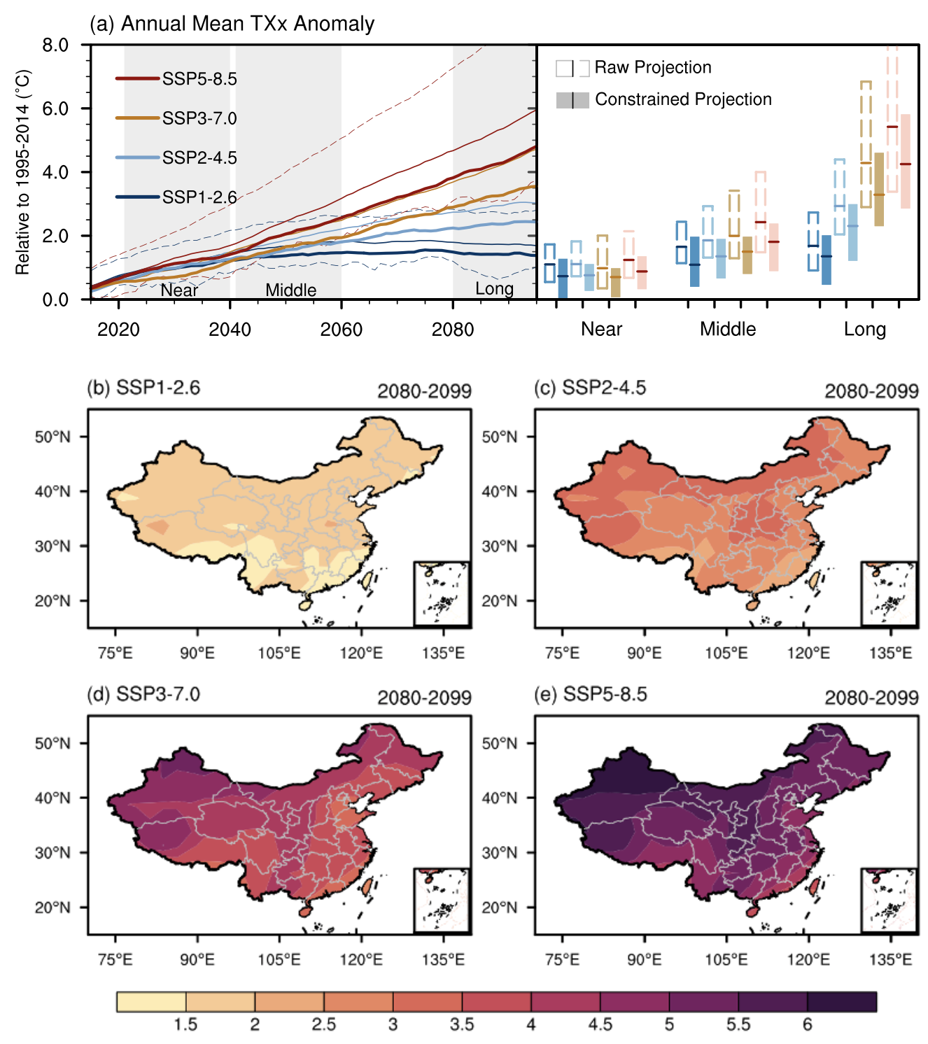

**Supplementary Fig. S1**. **The future increase of annual daily maximum temperature (TXx) over China in the raw and constrained projections** relative to 1995-2014. (a) The time series of 10-year running mean of extreme CSAT warming, and the bar chart on the right is the averaged warming in the near term (2021-2040), midterm (2041-2060) and long term (2080-2099). The thin solid lines are the multi-model ensemble (MME) of 18 CMIP6 models, and the dash lines represent the inter-model range of 5th and 95th percentiles under SSP1-2.6 and SSP5-8.5 scenarios. The hollow bars are the extreme CSAT warming in near-term, midterm, and long-term projections. The thick solid lines and the solid bars are the multi-model mean and inter-model range of 5th and 95th percentiles in the constrained projection. (b to e) the warming patterns of MME in the long term under four emission scenarios. Units: $℃$

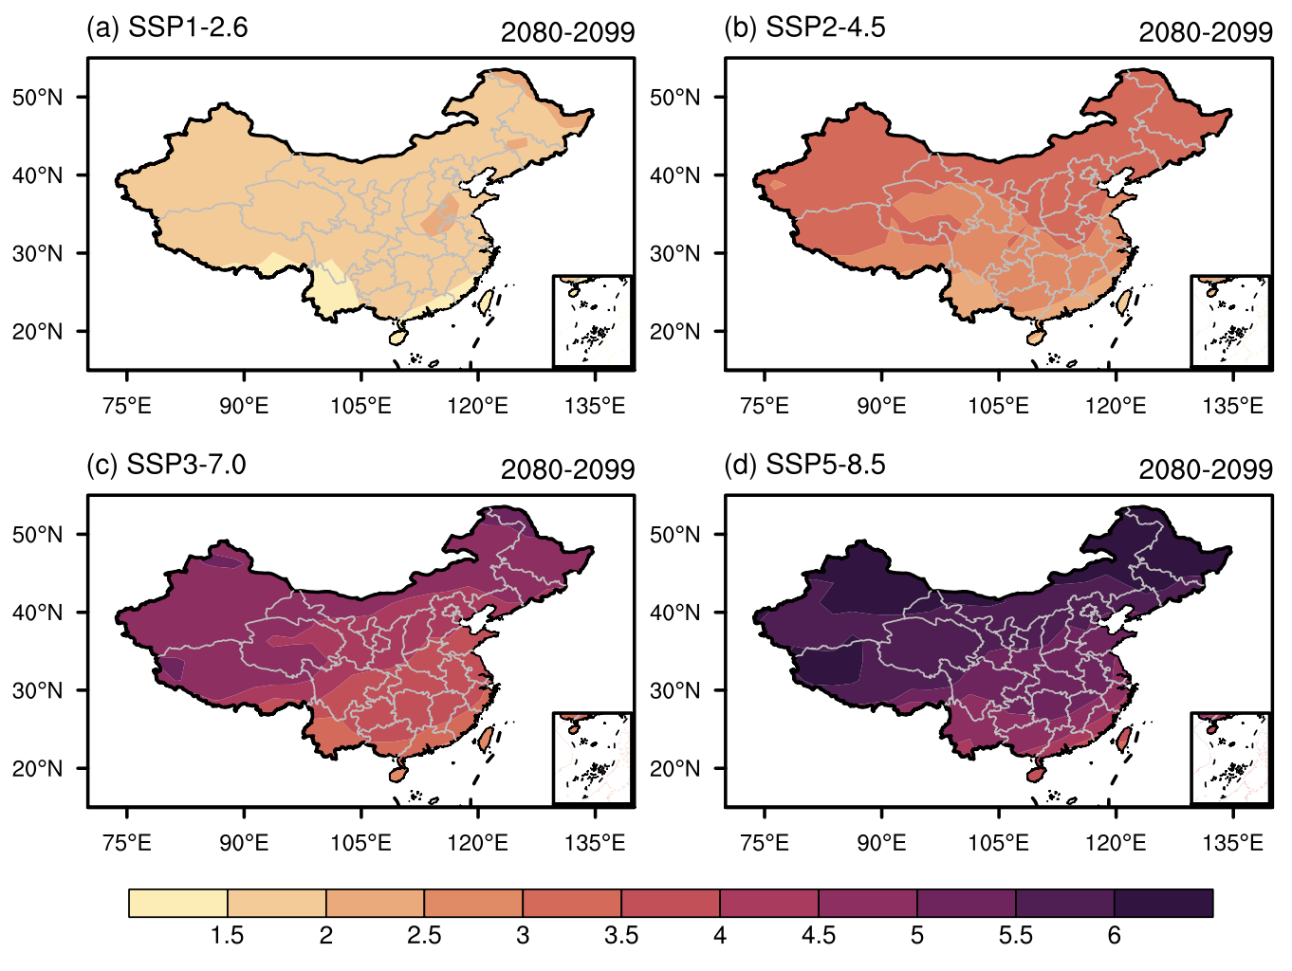

**Supplementary Fig. S2.** **The warming patterns of annual-mean surface air temperature** in CMIP6 multi-model ensemble mean in the long-term projection under four emission scenarios. Units: ℃

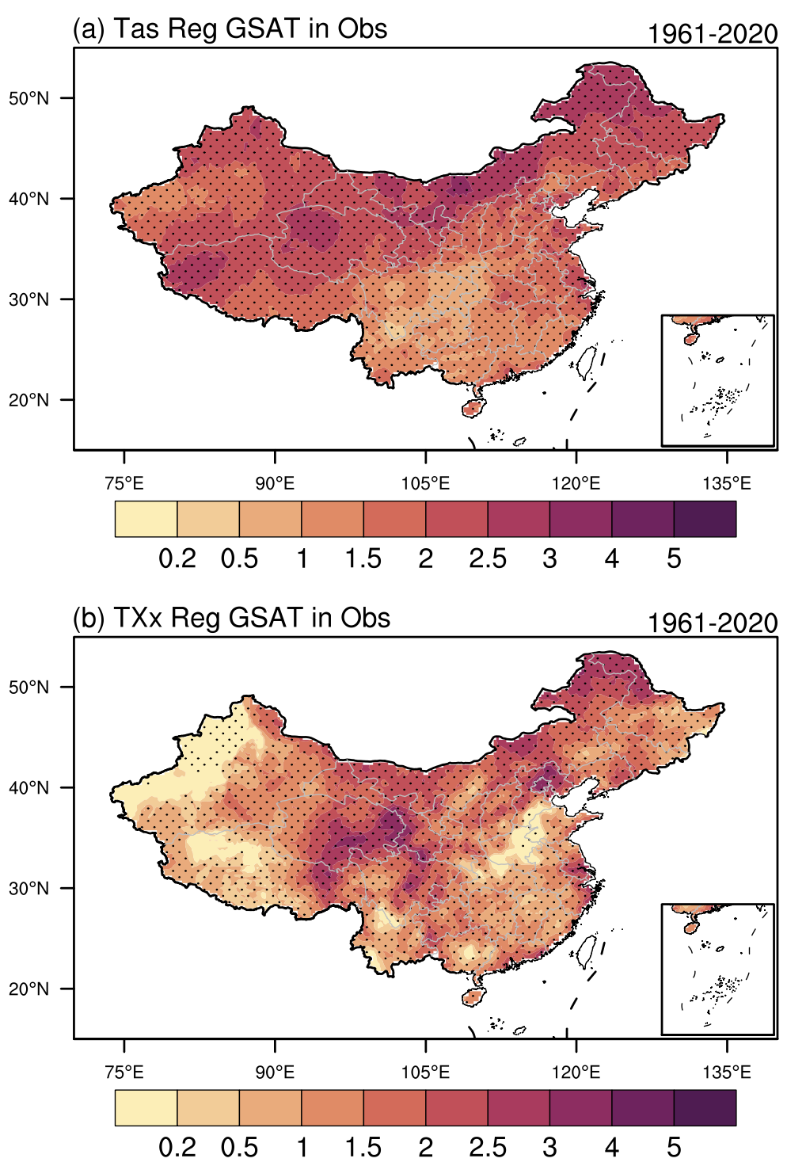

**Supplementary Fig. S3. Regional warming related to global surface air temperature (GSAT) in observations.** The spatial patterns show the regression coefficients between the annual mean surface air temperature and GSAT in (a) and between the daily maximum temperature (TXx) and GSAT in (b). We calculate the GSAT series by using three long-time observed datasets individually for the period of 1961~2020. And then we make the simple average of GSAT among the three observed datasets. All the data has been smooth with a 20-yr running mean filter. The black stippling indicates that the regression exceeds the 95% confidence level under the student-t test. Units: $°$ C/ $°$ C

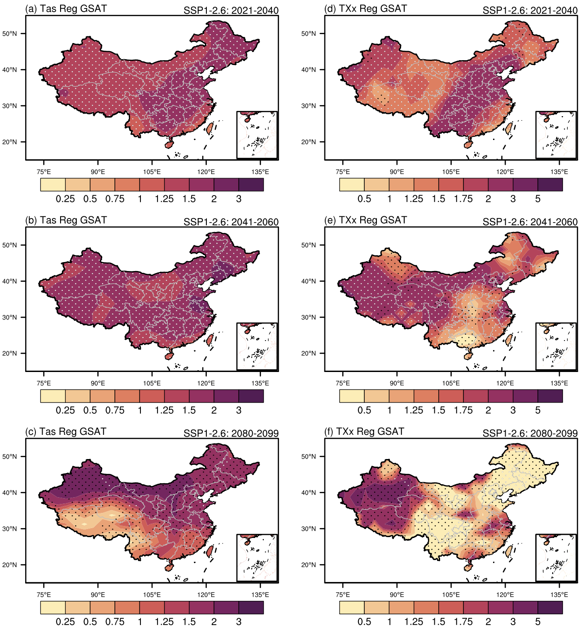

**Supplementary Fig. S4.** Same as Figure 2 but for SSP1-2.6 scenario.

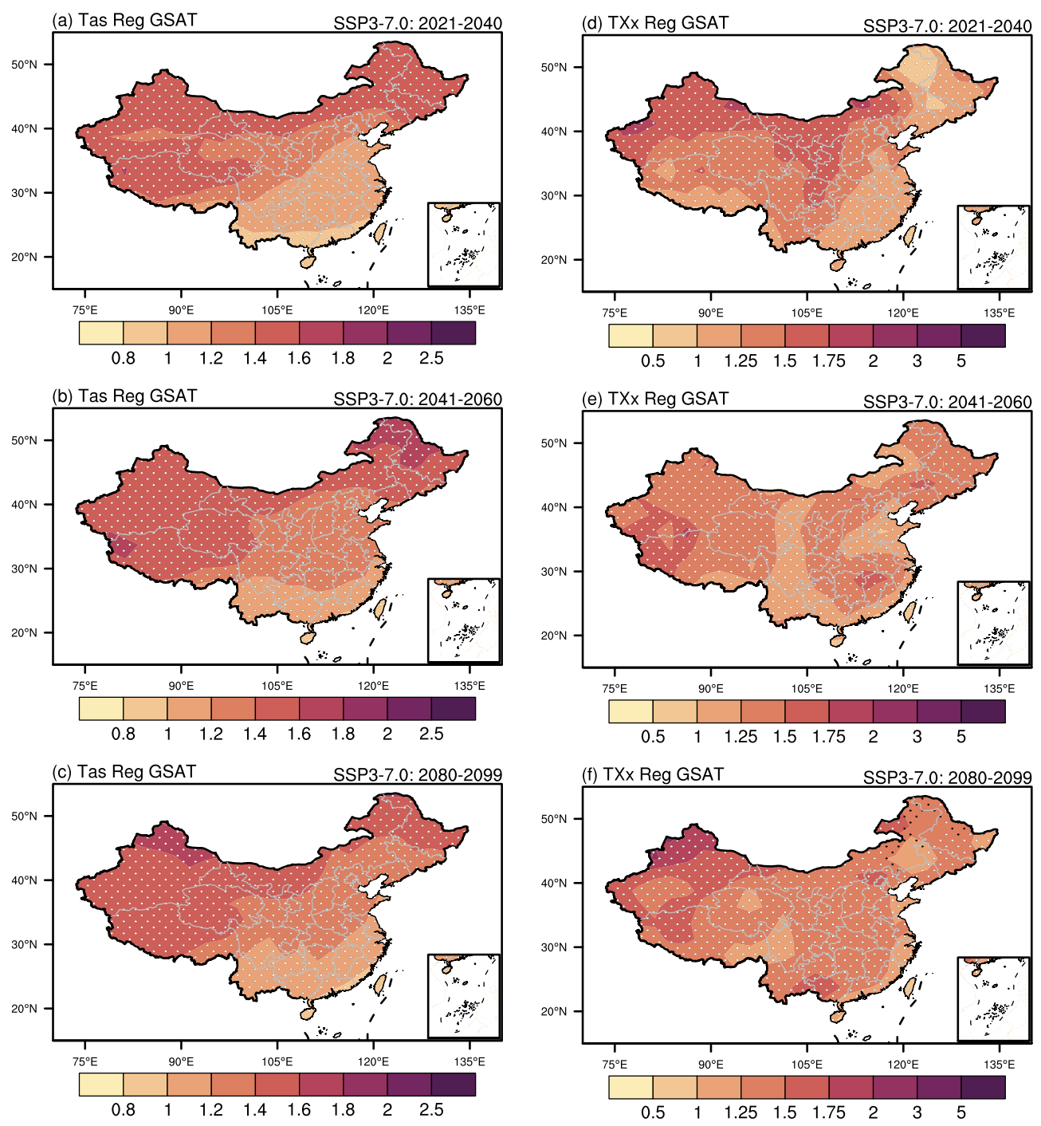

**Supplementary Fig. S5.** Same as Figure 2 but for SSP3-7.0 scenario.

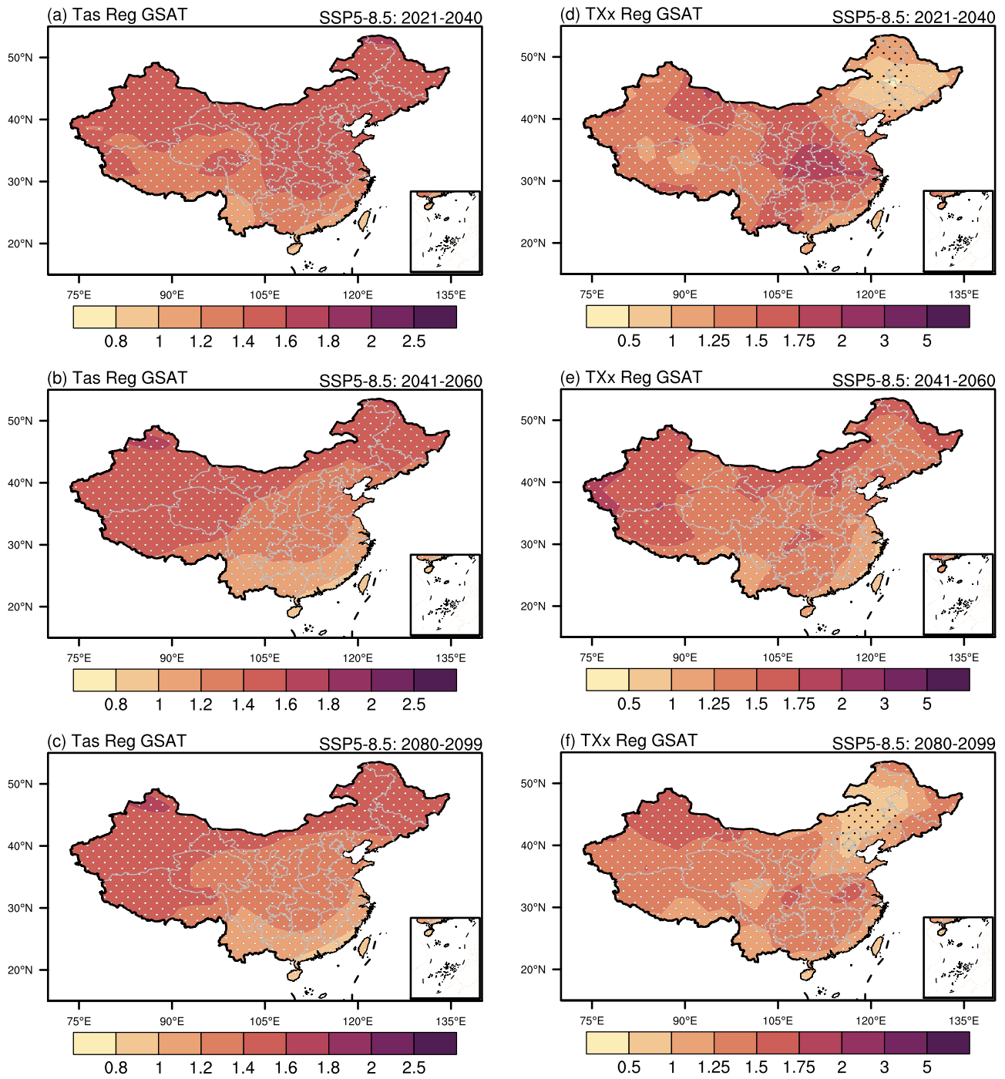

**Supplementary Fig. S6.** Same as Figure 2 but for SSP5-8.5 scenario.



**Supplementary Fig. S7. Scatter diagram between the warming trend of global surface air temperature (GSAT, units: 10 yr-1) for the period of 1981~2014 and the projected warming of GSAT** (units: $℃$) in the (a) near term, (b) midterm, and (c) long term under the SSP2-4.5 scenario. The black fitting line is obtained by the least square method, and the dashed curves denote the 95% prediction intervals of the linear regression. The gray vertical dashed line represents the mean of GSAT trend across multiple observation datasets, and the light gray shading denotes the range of the $±1$-time standard deviation across observation datasets.



**Supplementary Fig. S8.** Same as Supplementary Figure S7 but for (a1 to c1) SSP1-2.6, (a2 to c2) SSP3-7.0, and (a3 to c3) SSP5-8.5 scenarios.



**Supplementary Fig. S9.** Same as Supplementary Figure S7 but for the inter-model correlation between the present-day warming trend of global surface air temperature (GSAT) and the projected warming of surface air temperature over China (CSAT) under the (a1 to c1) SSP1-2.6, (a2 to c2) SSP2-4.5, and (a3 to c3) SSP3-7.0 and (a4 to c4) SSP5-8.5 scenarios.



**Supplementary Fig. S10.** Same as Supplementary Figure S9 but for the annual daily maximum temperature (TXx) over China.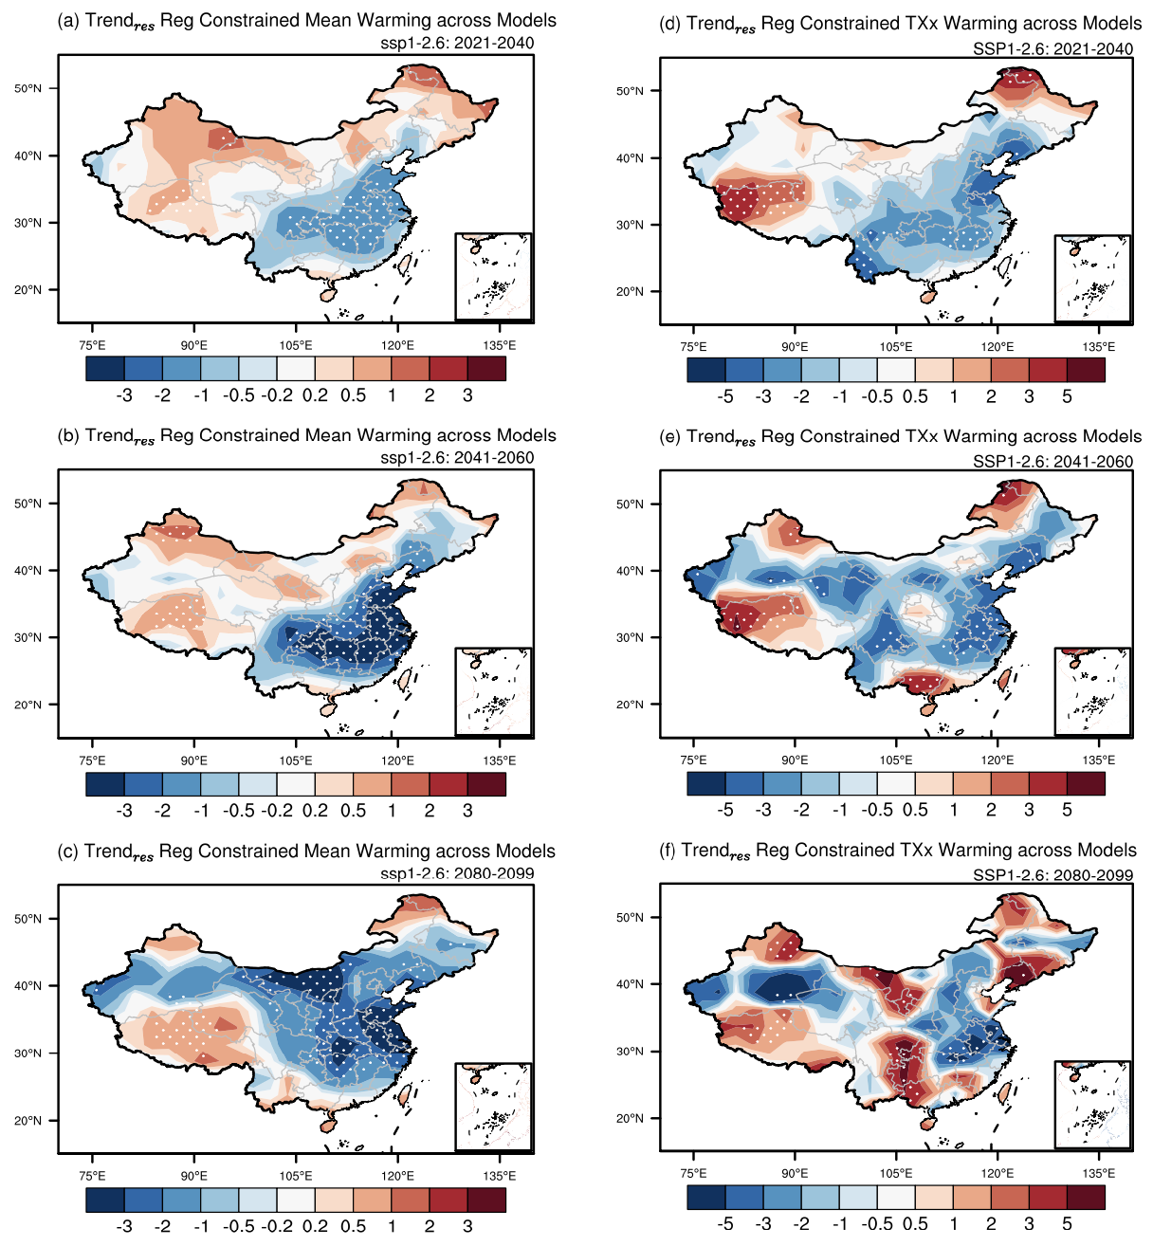

**Supplementary Fig. S11.** The projection of mean warming (a to c) and daily maximum temperature warming (TXx; d to f) in China constrained by global surface air temperature (GSAT) under SSP1-2.6 scenario regresses onto the local residual warming trend ($trend_{res}$) in 1981~2014 across models. Stippling represents the regression exceeds 90% confidence level under Student’s t test. Units: 10 yr-1.

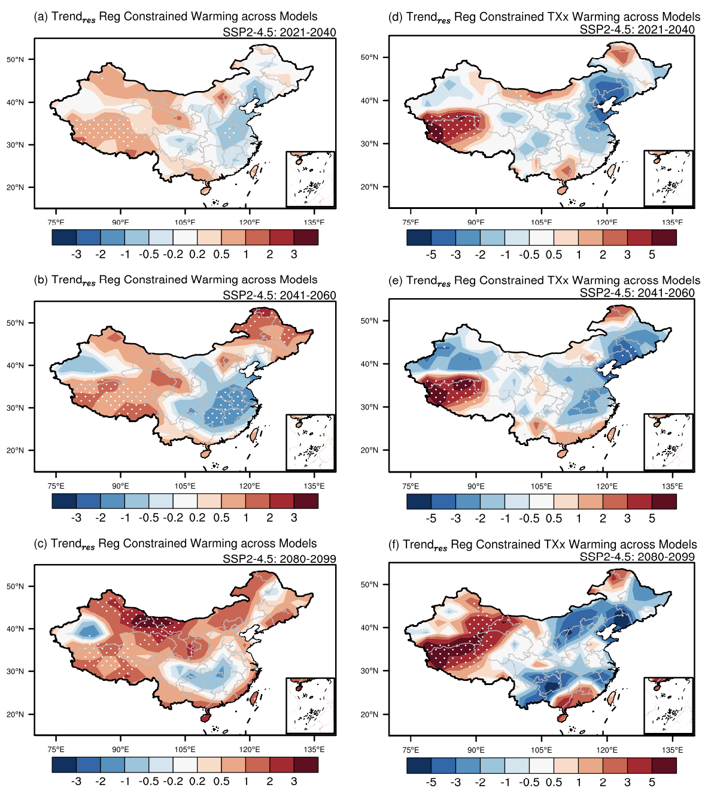

**Supplementary Fig. S12.** Same as Supplementary Fig. S10 but for the SSP2-4.5 scenario.

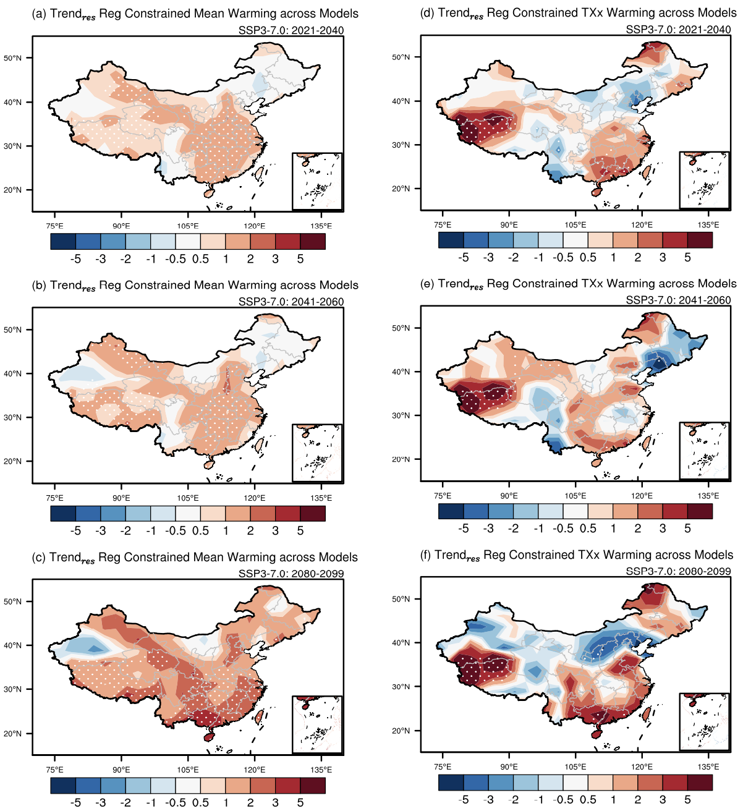

**Supplementary Fig. S13.** Same as Supplementary Fig. S10 but for the SSP3-7.0 scenario.

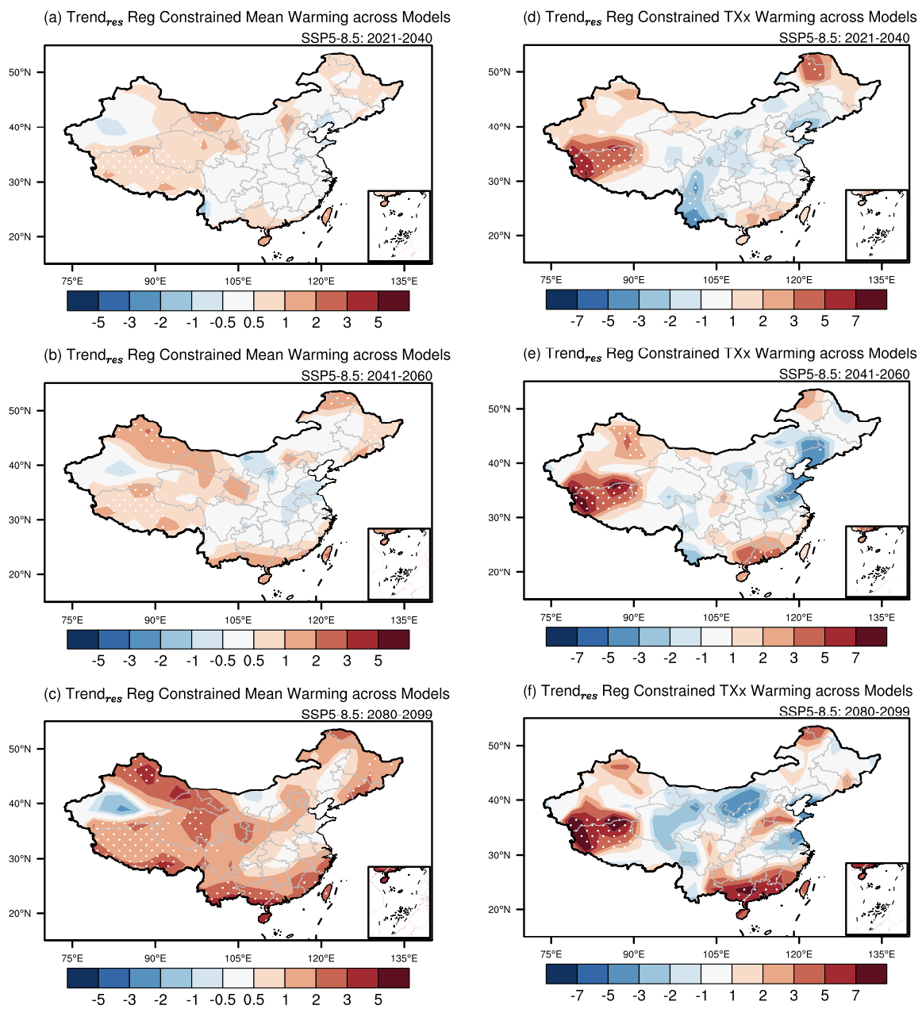

**Supplementary Fig. S14.** Same as Supplementary Fig. S10 but for the SSP5-8.5 scenario.

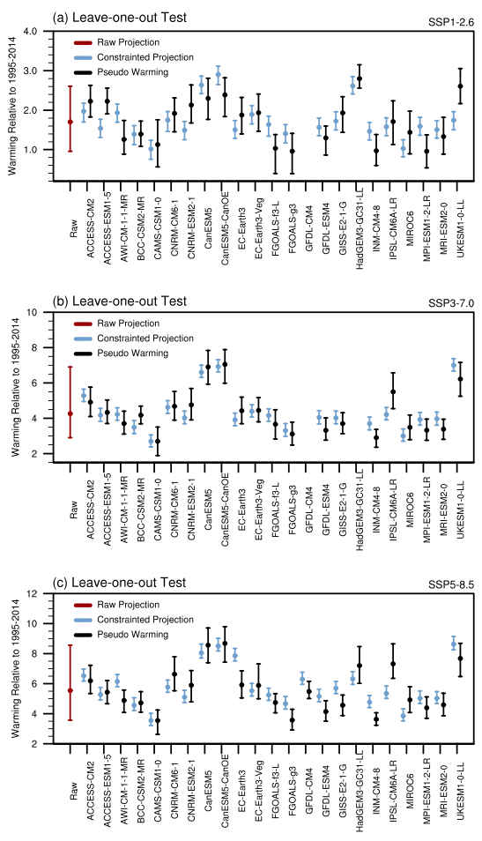

**Supplementary Fig. S15.** Same as Figure 1f but for the results under the (a) SSP1-2.6, (b) SSP3-7.0, and (c) SSP5-8.5 scenarios.

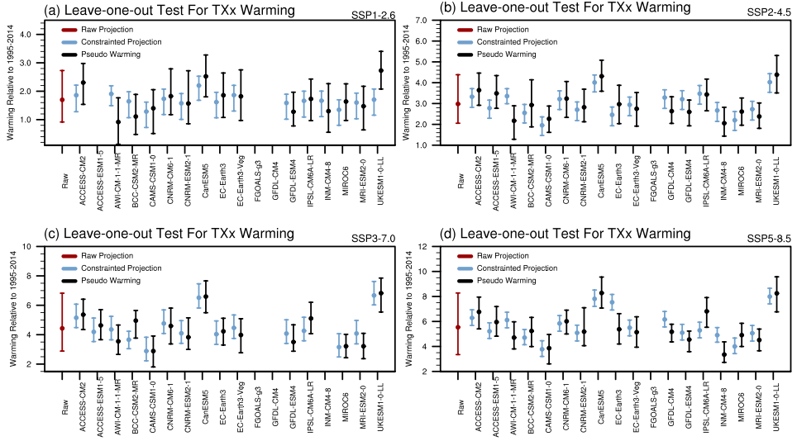

**Supplementary Fig. S16.** Same as Figure 1f but for the leave-one-out perfect model test of annual daily maximum temperature (TXx) warming under the (a) SSP1-2.6, (b) SSP2-4.5, (c) SSP3-7.0, and (d) SSP5-8.5 scenarios.

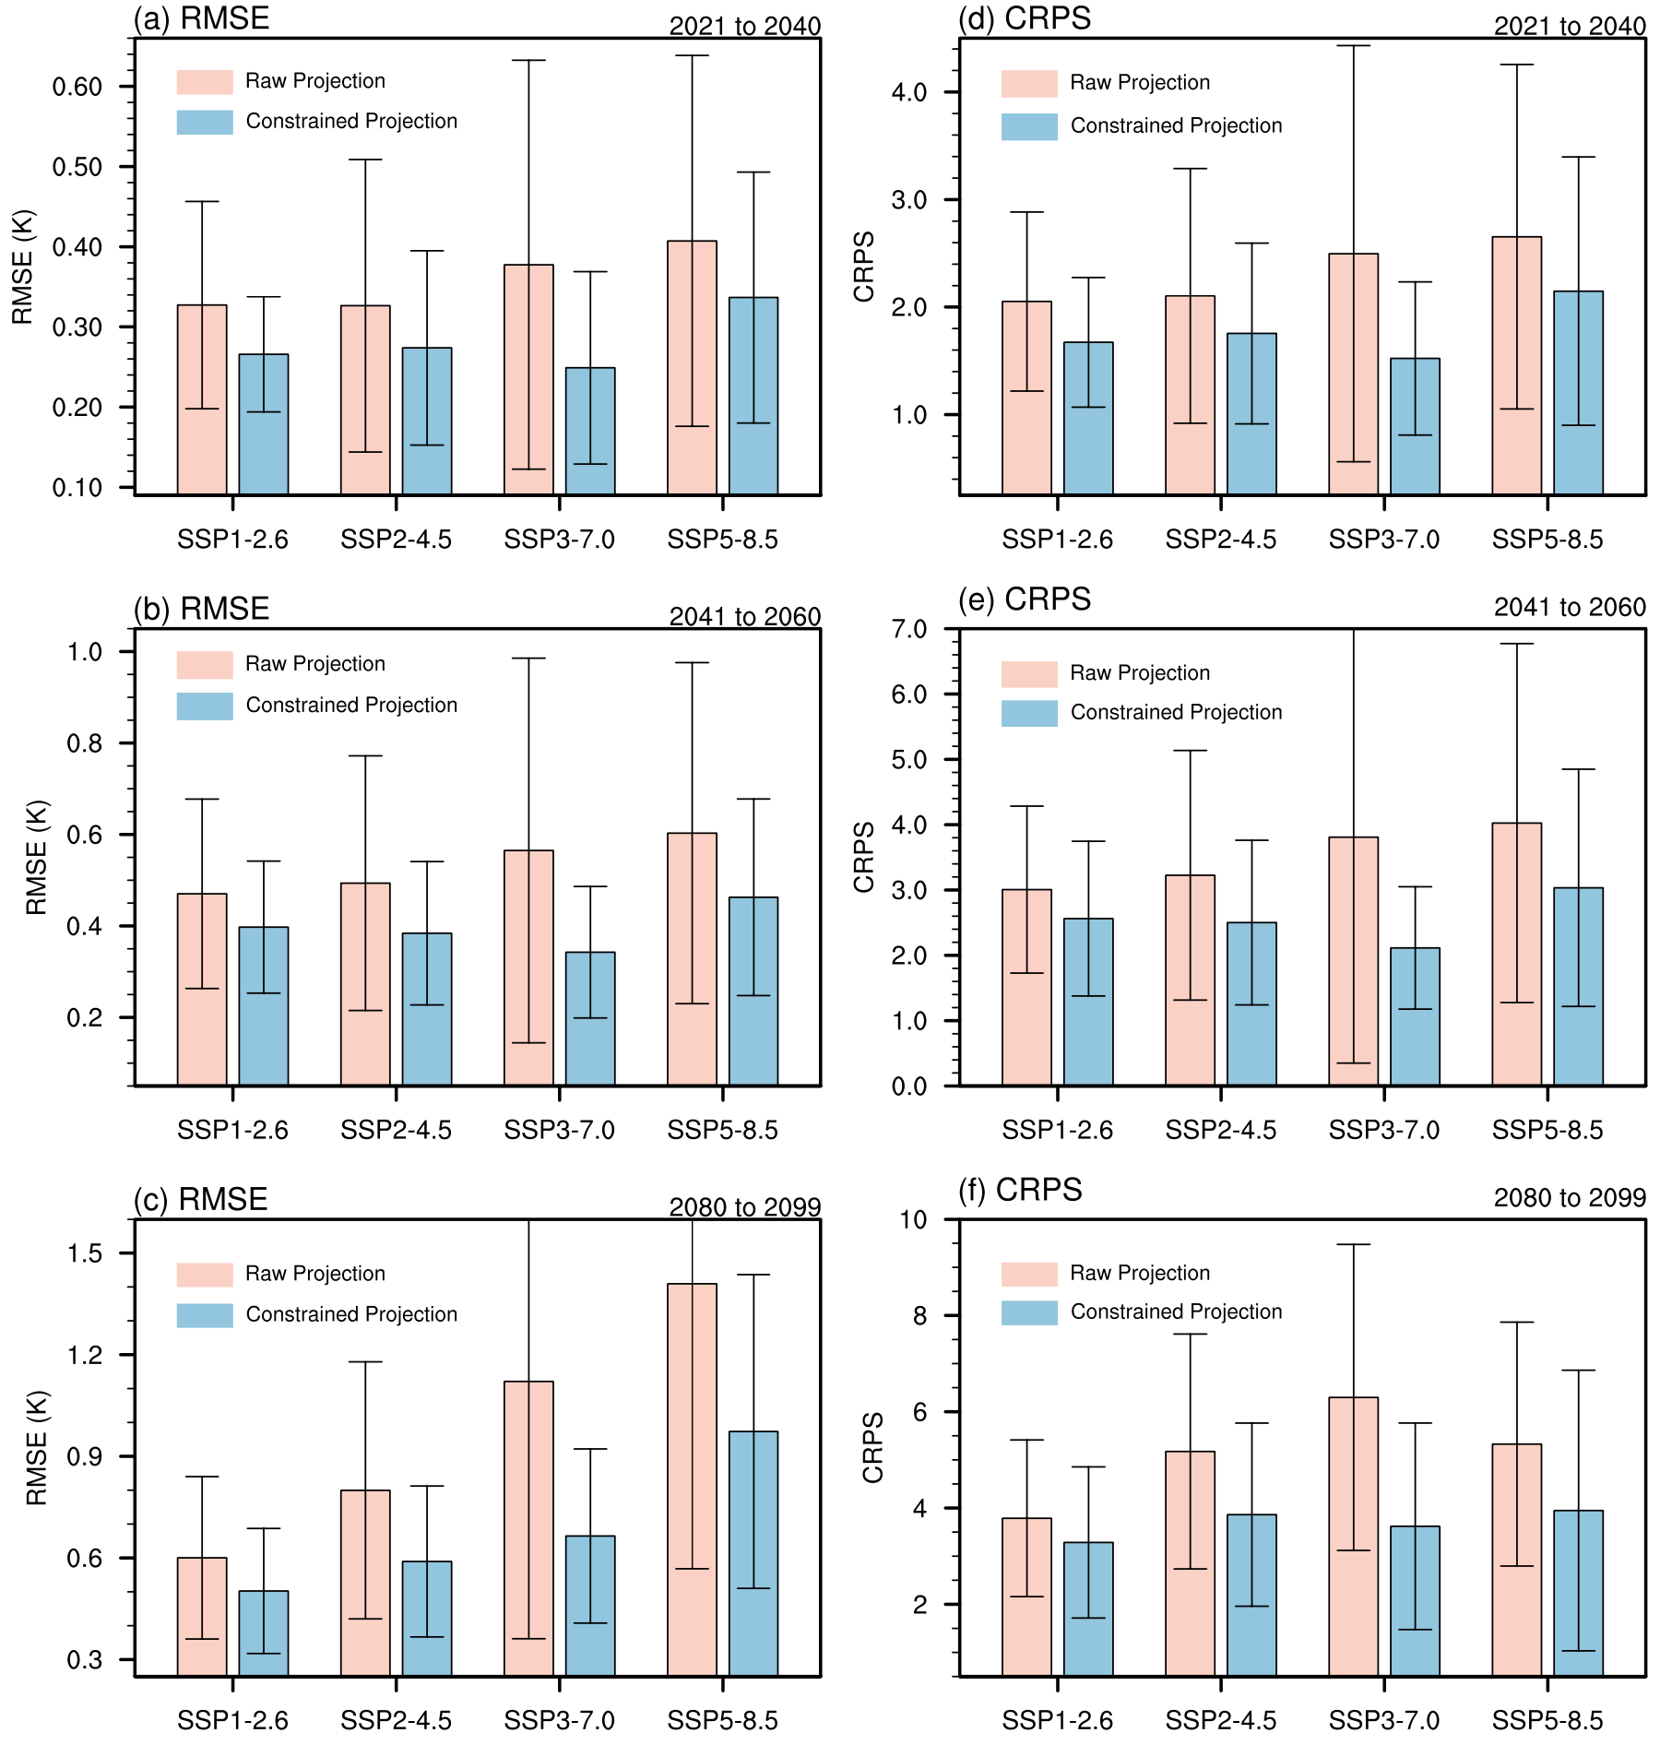

**Supplementary Fig. S17.** Root-mean-square errors (RMSEs, a to c) and continuous ranked probability skill scores (CRPSSs, d to f) in the raw (red) and constrained (blue) mean warming projections based on a leave-one-out perfect model test with CMIP6 for (a, d) near term, (b, e) midterm, and (c, f) long term. The x-axis shows the results under the four emission scenarios. The vertical lines represent the range of $±1$ inter-model standard deviation.

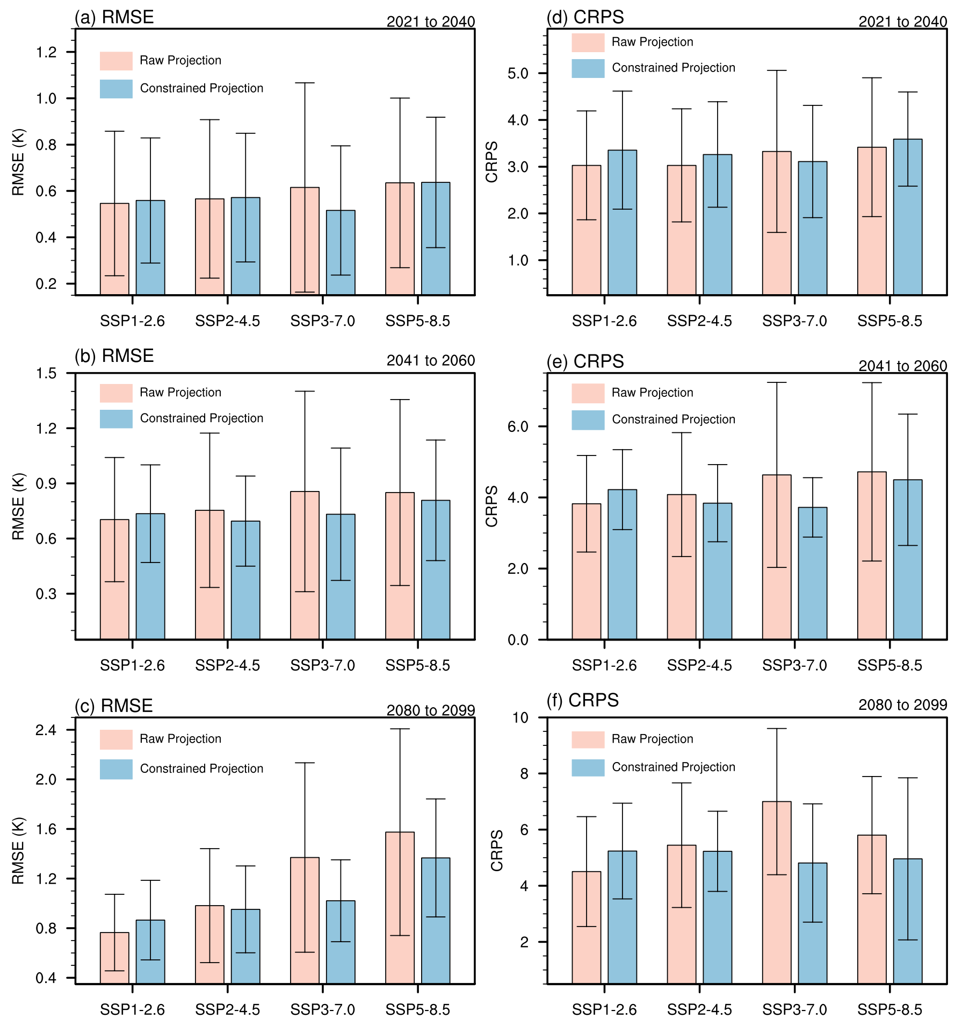

**Supplementary Fig. S18.** Same as Supplementary Fig. S17 but for the RMSEs and CRPSSs of daily maximum temperature (TXx) projection.

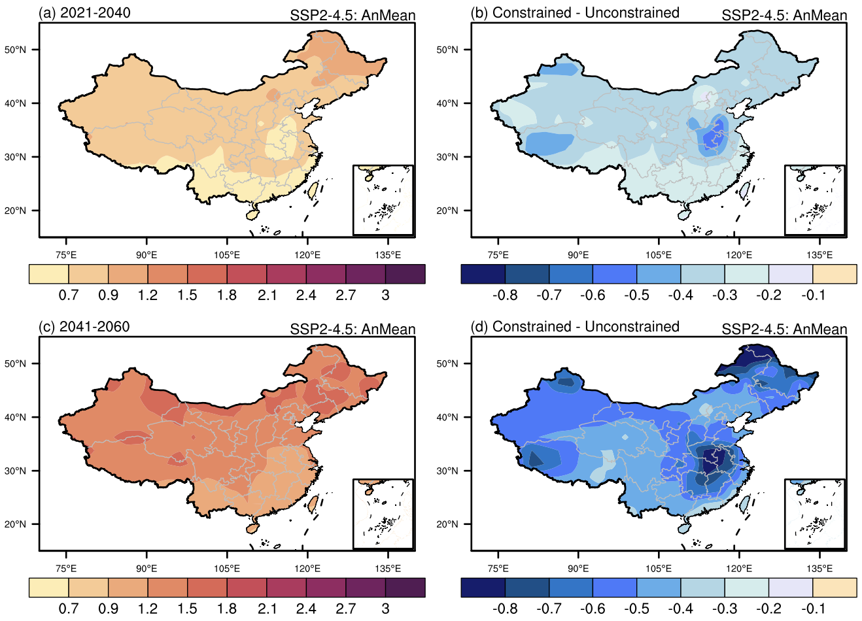

**Supplementary Fig. S19.** The constrained projection of annual mean surface air temperature over China and the difference between constrained and raw projection under the intermediate emission scenario (SSP2-4.5). (a) and (c) show the constrained warming over China in near term and midterm, respectively. (b) and (d) show the difference between constrained and raw projection in near term and midterm, respectively. Units: $°$ C

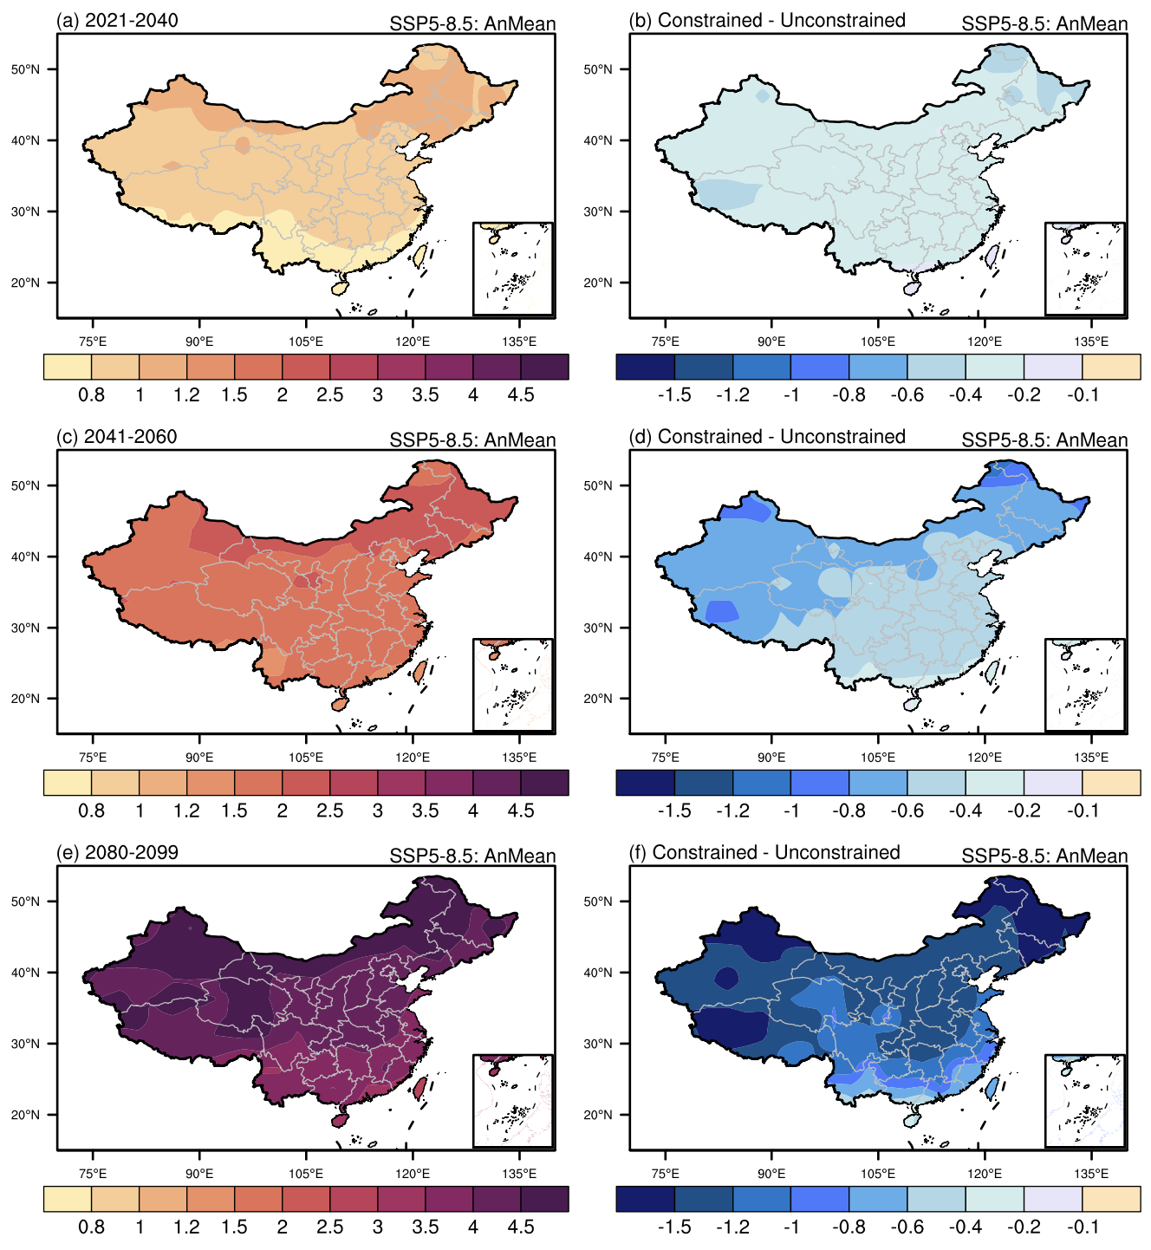

**Supplementary Fig. S20.** Same as Supplementary Figure S19, Figures 1b and 1c but for the high emission scenario (SSP5-8.5).

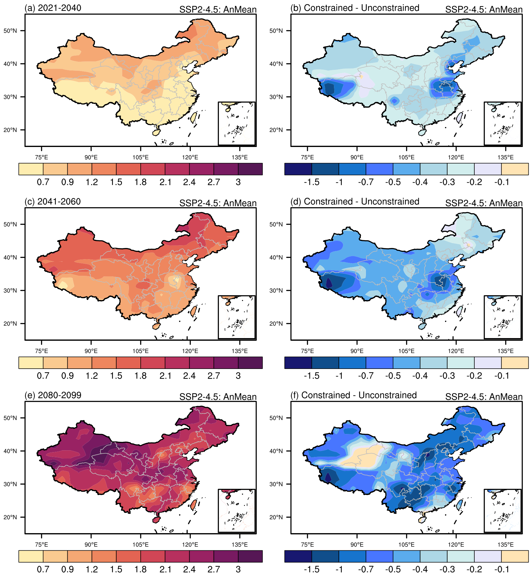

**Supplementary Fig. S21.** Under the intermediate emission scenario (SSP2-4.5), the constrained warming patterns of daily maximum temperature (TXx; a, c, e) and the difference between constrained and unconstrained warming (b, d, f) in (a, b) near term, (c, d) midterm, and (e, f) long term. Units: $℃$

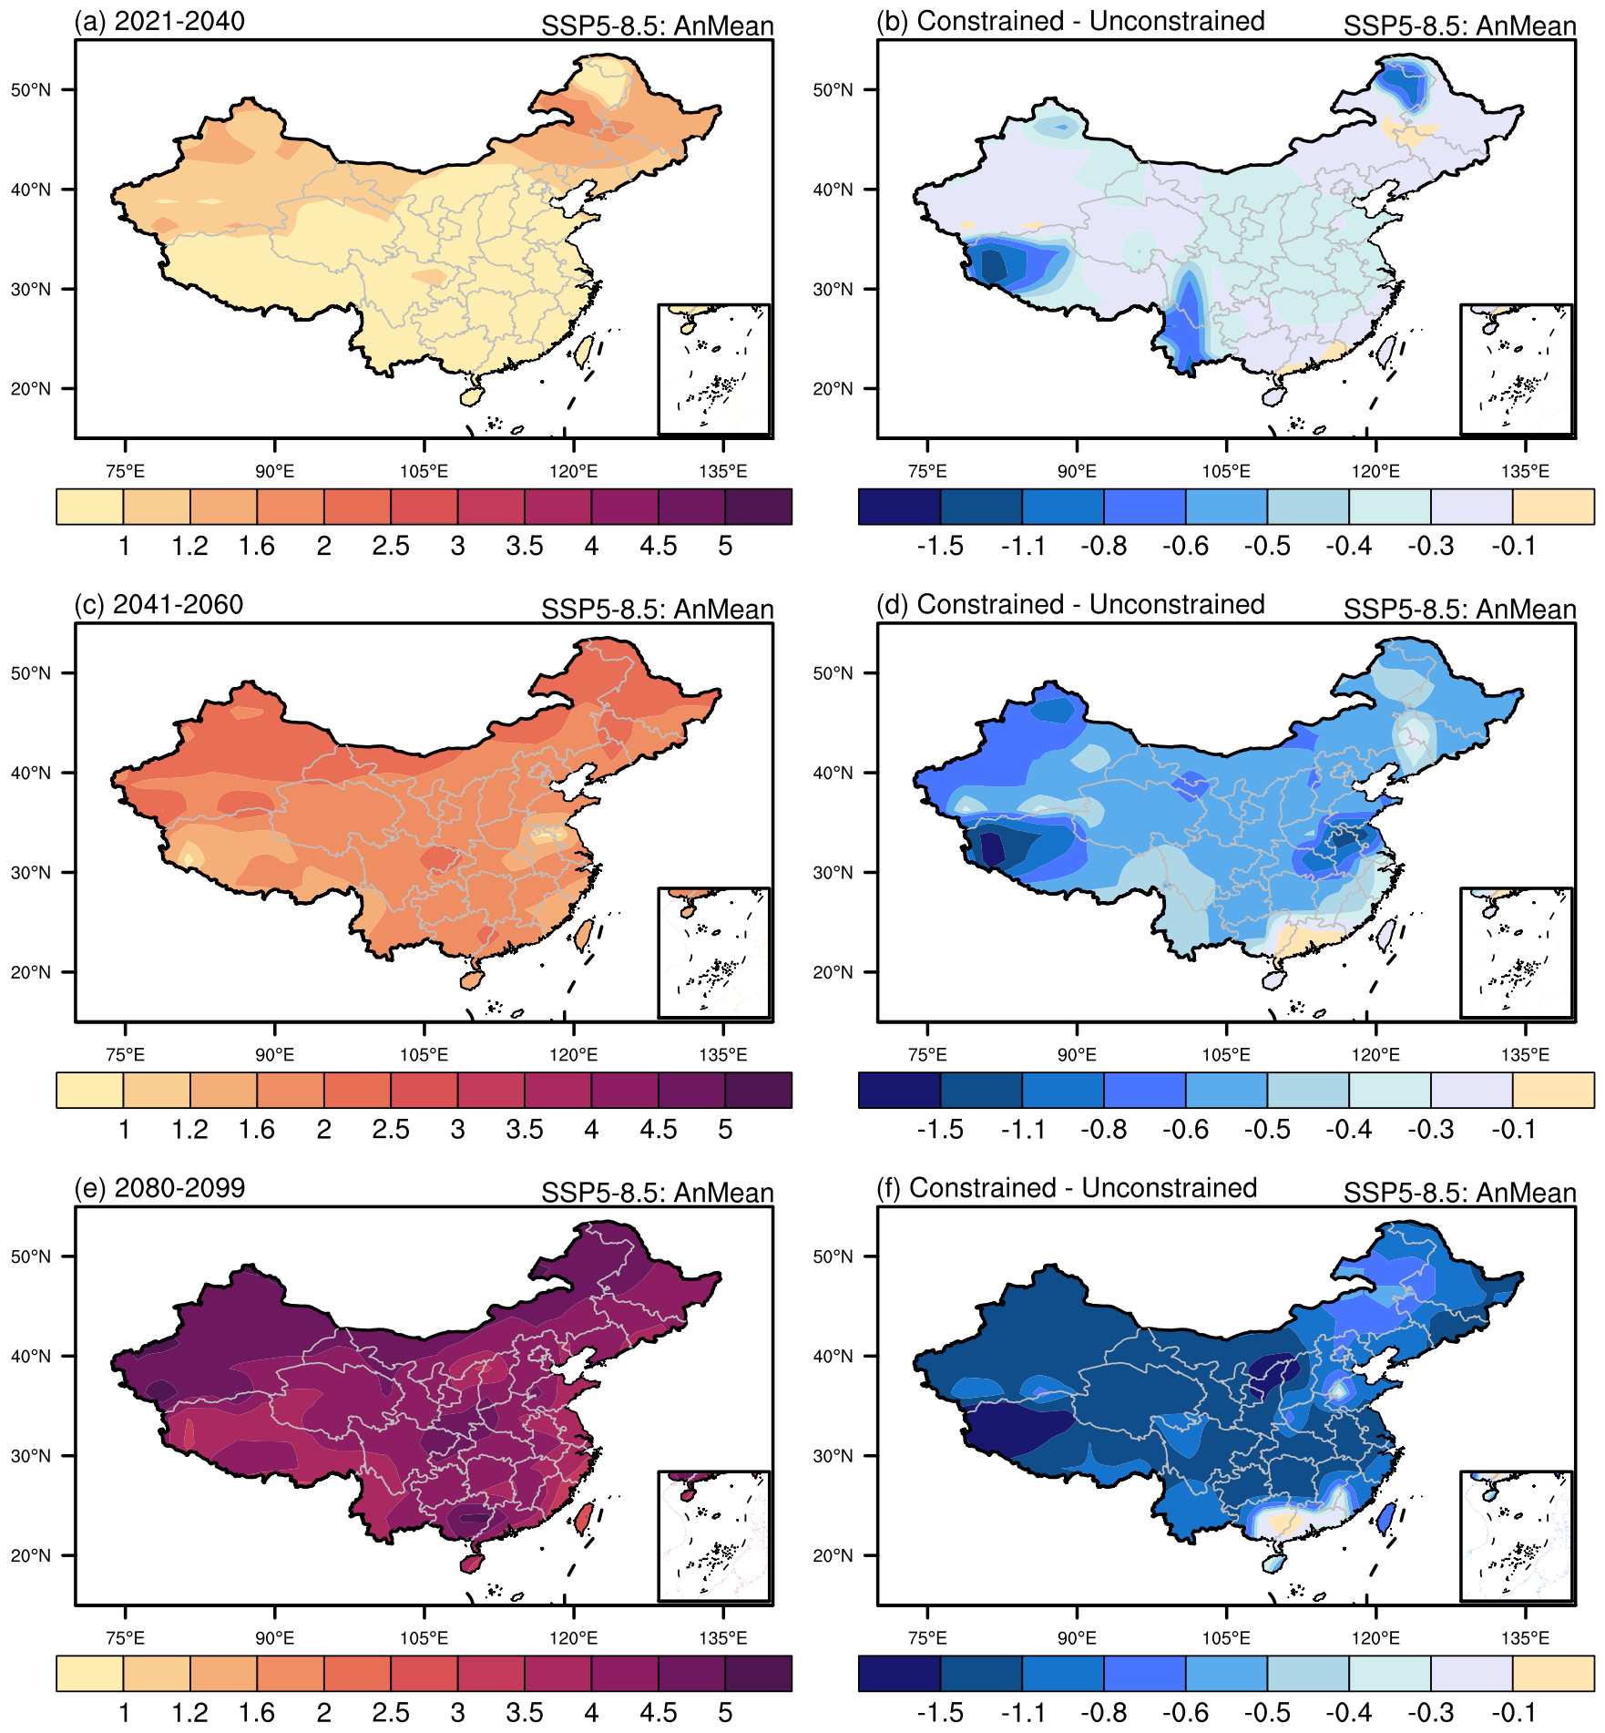

**Supplementary Fig. S22.** Under the high emission scenario (SSP5-8.5), the constrained warming patterns of daily maximum temperature (TXx; a, c, e) and the difference between constrained and unconstrained warming (b, d, f) in (a, b) near term, (c, d) midterm, and (e, f) long term. Units: $℃$

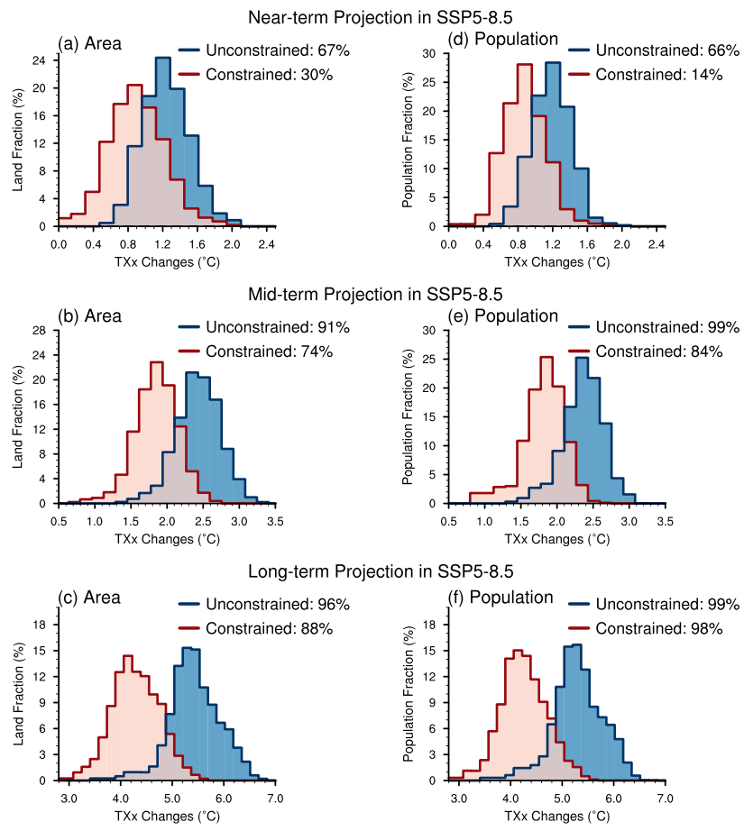

**Supplementary Fig. S23**. Same as Figure 3 but for the SSP5-8.5 scenario.

**References:**

Bowman, K. W., Cressie, N., Qu, X., & Hall, A. (2018). A hierarchical statistical framework for emergent constraints: application to snow‐albedo feedback. *Geophysical Research Letters*, *45*(23). https://doi.org/10.1029/2018gl080082

Brunner, L., Pendergrass, A. G., Lehner, F., Merrifield, A. L., Lorenz, R., & Knutti, R. (2020). Reduced global warming from CMIP6 projections when weighting models by performance and independence. *Earth System Dynamics*, *1*–*24*. https://doi.org/10.5194/esd-2020-23

Chen, X., Zhou, T., Wu, P., Guo, Z., & Wang, M. (2020). Emergent constraints on future projections of the western North Pacific Subtropical High. *Nature Communication*, *11*(1). https://doi.org/10.1038/s41467-020-16631-9

Chen, Z., Zhou, T., Zhang, W., Li, P., & Zhao, S. (2020). Projected Changes in the Annual Range of Precipitation Under Stabilized 1.5°C and 2.0°C Warming Futures. *Earth’s Future*, *8*(9). https://doi.org/10.1029/2019EF001435

Chen, Z., Zhou, T., Chen, X., Zhang, W., Zhang, L., Wu, M., & Zou, L. (2022). Observationally constrained projection of Afro-Asian monsoon precipitation. *Nature Communications*, *13*(1), 1–12. https://doi.org/10.1038/s41467-022-30106-z

Cowtan, K., & Way, R. G. (2014). Coverage bias in the HadCRUT4 temperature series and its impact on recent temperature trends. *Quarterly Journal of the Royal Meteorological Society*, *140*(683), 1935–1944. https://doi.org/10.1002/qj.2297

Cowtan, K., Hausfather, Z., Hawkins, E., Jacobs, P., Mann, M. E., Miller, S. K., et al. (2015). Robust comparison of climate models with observations using blended land air and ocean sea surface temperatures. *Geophysical Research Letters*, *42*(15), 6526–6534. https://doi.org/10.1002/2015gl064888

Fischer, E. M., & Knutti, R. (2014). Detection of spatially aggregated changes in temperature and precipitation extremes. *Geophysical Research Letters*, *41*(2), 547–554. https://doi.org/10.1002/2013gl058499

Fischer, E. M., Beyerle, U., & Knutti, R. (2013). Robust spatially aggregated projections of climate extremes. *Nature Climate Change*, *3*(12), 1033–1038. https://doi.org/10.1038/nclimate2051

Hawkins, E., & Sutton, R. (2009). The potential to narrow uncertainty in regional climate predictions. *Bulletin of the American Meteorological Society*, *90*(8), 1095–1108. https://doi.org/10.1175/2009bams2607.1

Hersbach, H. (2000). Decomposition of the continuous ranked probability score for ensemble prediction systems. *Weather and Forecasting*, *15*(5), 559–570. https://doi.org/10.1175/1520-0434(2000)015<0559:DOTCRP>2.0.CO;2

Hu, X. M., Ma, J. R., Ying, J., Cai, M., & Kong, Y. Q. (2021). Inferring future warming in the Arctic from the observed global warming trend and CMIP6 simulations. Advances in Climate Change Research, 12(4), 499–507. https://doi.org/10.1016/j.accre.2021.04.002

Jiménez-de-la-Cuesta, D., & Mauritsen, T. (2019). Emergent constraints on Earth’s transient and equilibrium response to doubled CO2 from post-1970s global warming. *Nature Geoscience*, *12*(11), 902–905. https://doi.org/10.1038/s41561-019-0463-y

Jones, B., & O’Neill, B. C. (2016). Spatially explicit global population scenarios consistent with the Shared Socioeconomic Pathways. *Environmental Research Letters*, *11*(8). https://doi.org/10.1088/1748-9326/11/8/084003

Lenssen, N., Schmidt, G., Hansen, J., Menne, M., Persin, A., Ruedy, R., & Zyss, D. (2019). Improvements in the GISTEMP uncertainty model. *Journal of Geophysical Research: Atmospheres*, *124*(12), 6307–6326. https://doi.org/10.1029/2018JD029522

Liang, Y., Gillett, N. P., & Monahan, A. H. (2020). Climate model projections of 21st century global warming constrained using the observed warming trend. *Geophysical Research Letters*, *47*(12). https://doi.org/10.1029/2019gl086757

Lee, J. Y., Marotzke, J., Bala, G., Cao, L., Corti, S., Dunne, J. P., et al. (2021). Chapter 4: Future global climate: scenario-based projections and near-term information. In V. Masson-Delmotte, P. Zhai, A. Pirani, S. L. Connors, C. Péan, S. Berger, et al. (Eds.), Climate Change 2021: The Physical Science Basis. Contribution of Working Group I to the Sixth Assessment Report of the Intergovernmental Panel on Climate Change. Cambridge University Press.

New, M., Hulme, M., & Jones, P. (2000). Representing twentieth-century space-time climate variability. Part II: Development of 1901-96 monthly grids of terrestrial surface climate. *Journal of Climate*, *13*(13), 2217–2238. https://doi.org/10.1175/1520-0442(2000)013<2217:RTCSTC>2.0.CO;2

Nijsse, F. J. M. M., Cox, P. M., Huntingford, C., & Williamson, M. S. (2019). Decadal global temperature variability increases strongly with climate sensitivity. *Nature Climate Change*, *9*(8), 598–601. https://doi.org/10.1038/s41558-019-0527-4

Rohde, R., Muller, R., Jacobsen, R., Perlmutter, S., & Mosher, S. (2013). Berkeley Earth temperature averaging process. *Geoinformatics & Geostatistics: An Overview*, *01*(02). https://doi.org/10.4172/2327-4581.1000103

Schleussner, C.-F., Pfleiderer, P., & Fischer, E. M. (2017). In the observational record half a degree matters. *Nature Climate Change*, *7*(7), 460–462. https://doi.org/10.1038/nclimate3320

Simpson, I. R., McKinnon, K. A., Davenport, F. V., Tingley, M., Lehner, F., Al Fahad, A., & Chen, D. (2021). Emergent constraints on the large-scale atmospheric circulation and regional hydroclimate: Do they still work in CMIP6 and how much can they actually constrain the future? *Journal of Climate*, *34*(15), 6355–6377. https://doi.org/10.1175/JCLI-D-21-0055.1

Tokarska, K. B., Stolpe, M. B., Sippel, S., Frischer, E. M., Smith, C. J., Lehner, F., & Knutti, R. (2020). Past warming trend constrains future warming in CMIP6 models. *Science Advances*, *6*(12). https://doi.org/10.1126/sciadv.aaz9549

Vose, R. S., Arndt, D., Banzon, V. F., Easterling, D. R., Gleason, B., Huang, B., et al. (2012). NOAA’s merged land-ocean surface temperature analysis. *Bulletin of the American Meteorological Society*, *93*(11), 1677–1685. https://doi.org/10.1175/BAMS-D-11-00241.1

Wu, J., & Gao, X. (2013). A gridded daily observation dataset over China region and comparison with the other datasets. *Chinese Journal of Geophysics*, *56*(4), 1102–1111. https://doi.org/10.6038/CJG20130406

Zhang, H.-M., Lawrimore, J. H., Huang, B., Menne, M. J., Yin, X., Sȧnchez-Lugo, A., et al. (2019). Updated temperature data give a sharper view of climate trends. *Eos*, *100*. https://doi.org/10.1029/2019EO128229

Zhang, W., & Zhou, T. (2020). Increasing impacts from extreme precipitation on population over China with global warming, *65*, 243–252.

Zhao, S., & Zhou, T. (2019). Are the Observed Changes in Heat Extremes Associated With a Half‐Degree Warming Increment Analogues for Future Projections? *Earth’s Future*, *7*(8), 978–992. https://doi.org/10.1029/2019ef001237

Zhao, S., Zhou, T., & Chen, X. (2020). Consistency of extreme temperature changes in China under a historical half-degree warming increment across different reanalysis and observational datasets. *Climate Dynamics*, *54*(3–4), 2465–2479. https://doi.org/10.1007/s00382-020-05128-2